**VIVEKANAND EDUCATION SOCIETY’S INSTITUTE OF TECHNOLOGY**

**An Autonomous Institute Affiliated to University of Mumbai**

**Department of Computer Engineering**



Project Report on

# **ToothBuddy : Remote Dental Diagnostic and Consultation System**

In partial fulfillment of the Fourth Year, Bachelor of Engineering (B.E.) Degree in Computer Engineering at the University of Mumbai Academic Year 2024-25

**Submitted by**

Mahendra Girase(D17 - B , Roll no - 14 )

Mohit Patil (D17 - B , Roll no - 39 )

Pranav Rane(D17 - B , Roll no - 43 )

Amisha Chandwan**i** (D17 - A , Roll no - 02 )

**Project Mentor**

Prof. Mannat Doultani

(2024-25)

**VIVEKANAND EDUCATION SOCIETY’S INSTITUTE OF TECHNOLOGY**

**An Autonomous Institute Affiliated to University of Mumbai**

**Department of Computer Engineering**



**Certificate**

This is to certify that ***Mahendra Girase, Pranav Rane, Mohit Patil, Amisha Chandwani*** of Fourth Year Computer Engineering studying under the University of Mumbai have satisfactorily completed the project on “***ToothBuddy : Remote Dental Diagnostic and Consultation System***” as a part of their coursework of PROJECT-II for Semester-VIII under the guidance of their mentor ***Prof.Mannat Doultani*** in the year 2024-25 .

This project report entitled “***ToothBuddy : Remote Dental Diagnostic and Consultation System***” by ***Mahendra Girase, Pranav Rane, Mohit Patil, Amisha Chandwani***  is approved for the degree of B.E. (Computer Engineering).

| Programme Outcomes | Grade |
| --- | --- |
| PO1,PO2,PO3,PO4,PO5,PO6,PO7,  PO8, PO9, PO10, PO11, PO12  PSO1, PSO2 |  |

Date:

Project Guide:

---------------------------------------------

**Project Report Approval**

**For**

**B. E (Computer Engineering)**

This project report entitled “***ToothBuddy : Remote Dental Diagnostic and Consultation System***” by ***Mahendra Girase, Pranav Rane, Mohit Patil, Amisha Chandwani***  is approved for the degree of B.E. (Computer Engineering).

Internal Examiner

---------------------------------------------

External Examiner

---------------------------------------------

Head of the Department

-----------------------------------------------

Principal

-----------------------------------------------

Date:

Place:Mumbai

**Declaration**

We declare that this written submission represents our ideas in our own words and where others' ideas or words have been included, we have adequately cited and referenced the original sources. We also declare that we have adhered to all principles of academic honesty and integrity and have not misrepresented or fabricated or falsified any idea/data/fact/source in our submission. We understand that any violation of the above will be cause for disciplinary action by the Institute and can also evoke penal action from the sources which have thus not been properly cited or from whom proper permission has not been taken when needed.

| -----------------------------------------  (Signature)  -----------------------------------------  Mahendra Girase D17B/14 | -----------------------------------------  (Signature)  -----------------------------------------  Mohit Patil D17B/39 |
| --- | --- |
| -----------------------------------------  (Signature)  -----------------------------------------  Pranav Rane D17B/43 | -----------------------------------------  (Signature)  -----------------------------------------  Amisha Chandwani D17C/02 |

Date:

**ACKNOWLEDGEMENT**

We are thankful to our college Vivekanand Education Society’s Institute of Technology for considering our project and extending help at all stages needed during our work of collecting information regarding the project.

It gives us immense pleasure to express our deep and sincere gratitude to Assistant Professor **Prof. Mannat Doultani** for her kind help and valuable advice during the development of project synopsis and for her guidance and suggestions.

We are deeply indebted to Head of the Computer Department **Dr.(Mrs.) Nupur Giri** and our Principal **Dr. (Mrs.) J.M. Nair ,** for giving us this valuable opportunity to do this project.

We express our hearty thanks to them for their assistance without which it would have been difficult in finishing this project synopsis and project review successfully.

We convey our deep sense of gratitude to all teaching and non-teaching staff for their constant encouragement, support and selfless help throughout the project work. It is a great pleasure to acknowledge the help and suggestion, which we received from the Department of Computer Engineering.

We wish to express our profound thanks to all those who helped us in gathering information about the project. Our families too have provided moral support and encouragement several times.

**Computer Engineering Department  
COURSE OUTCOMES FOR B.E PROJECT**

Learners will be to,

| **Course Outcome** | **Description of the Course Outcome** |
| --- | --- |
| CO 1 | Able to apply the relevant engineering concepts, knowledge and skills towards the project. |
| CO2 | Able to identify, formulate and interpret the various relevant research papers and to determine the problem. |
| CO 3 | Able to apply the engineering concepts towards designing solutions for the problem. |
| CO 4 | Able to interpret the data and datasets to be utilized. |
| CO 5 | Able to create, select and apply appropriate technologies, techniques, resources and tools for the project. |
| CO 6 | Able to apply ethical, professional policies and principles towards societal, environmental, safety and cultural benefit. |
| CO 7 | Able to function effectively as an individual, and as a member of a team, allocating roles with clear lines of responsibility and accountability. |
| CO 8 | Able to write effective reports, design documents and make effective presentations. |
| CO 9 | Able to apply engineering and management principles to the project as a team member. |
| CO 10 | Able to apply the project domain knowledge to sharpen one’s competency. |
| CO 11 | Able to develop a professional, presentational, balanced and structured approach towards project development. |
| CO 12 | Able to adopt skills, languages, environment and platforms for creating innovative solutions for the project. |

**Index**

**Title page no.**

**Abstract 10**

**Chapter 1: Introduction 11**

1.1 Introduction 11

1.2 Motivation 11

1.3 Problem Definition 12

1.4 Existing Systems 13

1.5 Lacuna in Existing Systems 13

1.6 Relevance of the Project 14

**Chapter 2: Literature Survey 15**

A. Brief Overview of Literature Survey 15

B. Related Works 16

2.1 Research Papers Referred 17

2.2 Patent search Links 22

1) European Patent 22

2) US Patent 22

2.3 Inference Drawn 23

2.4 Comparison with the existing system 24

**Chapter 3: Requirement Gathering for the Proposed System 26**

3.1 Introduction to Requirement Gathering 26

3.2 Functional Requirements 26

3.3 Non-Functional Requirements 28

3.4 Hardware, Software, Technology, and Tools Utilized 29

3.5 Constraints 30

**Chapter 4: Proposed Design 31**

4.1 Block diagram of the system 31

4.2 Modular design of the system 32

4.3 Detailed Design 33

4.4 Project Scheduling & Tracking using Timeline / Gantt Chart 37

**Chapter 5: Implementation of the Proposed System 38**

5.1 Methodology Employed for Development 38

5.2 Algorithms and Flowcharts for the Respective Modules Developed 40

5.3 Datasets source and utilization 43

**Chapter 6: Testing of the Proposed System 46**

6.1. Introduction to Testing 46

6.2. Types of Tests Considered 46

6.3. Various Test Case Scenarios Considered 47

6.4. Inference Drawn from the Test Cases 48

**Chapter 7: Results and Discussion 49**

7.2. Performance Evaluation Measures 51

7.3. Input Parameters / Features Considered 52

7.4. Graphical and Statistical Output 52

7.5. Comparison of Results with Existing Systems 53

7.6. Inference Drawn 54

**Chapter 8: Conclusion 55**

8.1 Limitations 55

8.2 Conclusion 56

8.3 Future Scope 56

**References 58**

**Appendix 60**

**1. Paper I details 61**

a. Research Paper 61

b. Plagiarism Report 70

c. Review Sheets 71

**List of Figures**

| **Fig. No.** | **Heading** | **Page No.** |
| --- | --- | --- |
| 4.1 | Block Diagram of the System | 31 |
| 4.2 | Modular Diagram of the System | 32 |
| 4.3 | DFD Level 0 | 33 |
| 4.4 | DFD Level 1 | 33 |
| 4.5 | DFD Level 2 | 34 |
| 4.6 | State Transition Diagram | 35 |
| 4.7 | ER Diagram | 36 |
| 4.8 | Gantt Chart | 37 |
| 5.1 | Flowchart of Patients App | 41 |
| 5.2 | Flowchart of Dentists App | 42 |
| 7.1 | Patients App Interface Screenshots | 49 |
| 7.2 | Dentists App Interface Screenshots | 50 |

**List of Tables**

| **Table No.** | **Heading** | **Page No.** |
| --- | --- | --- |
| 2.1 | Comparison with Existing System | 24-25 |
| 5.1 | Dataset Summary | 43 |
| 7.1 | Models Comparison | 51 |

# Abstract

Oral health plays a vital role in maintaining overall well-being, yet many people neglect regular dental check-ups due to lack of awareness, access, or time. To address this issue, we have developed a mobile-based application titled "ToothBuddy" that enables early detection of oral diseases and facilitates seamless consultation with dental professionals.

This system consists of two mobile applications: one for patients and another for dentists. The patient-side application allows users to register or log in, capture an image of the affected area in the mouth, and detect the disease using an advanced image classification and object detection model — YOLOv11. Once a disease is identified, a report is automatically generated based on the user’s profile and detection results. The patient can then view a list of available dentists and connect with them by sending the report.

On the doctor’s side, the application allows login access to view patient appointment requests, review the diagnostic reports, chat with patients, and even conduct video consultations for better analysis and treatment advice. In addition, the system includes a chatbot that provides patients with useful oral hygiene tips and preliminary guidance.

By combining artificial intelligence, real-time communication, and healthcare services, this project aims to revolutionize oral healthcare by making it more accessible, proactive, and user-friendly.

# Chapter 1: Introduction

## 1.1 Introduction

Oral health represents an essential component of a person’s overall physical and mental well-being. Despite its importance, it is often overlooked in regular health practices. Dental problems such as cavities, gum infections, and ulcers can usually be either prevented or managed effectively when diagnosed in the early stages. However, a significant barrier to timely diagnosis and treatment is the lack of access to dental professionals, particularly in remote, rural, and economically underdeveloped regions. In such areas, many individuals do not have the means or opportunity to seek regular dental care, which results in dental conditions going unnoticed and untreated for extended periods. These untreated issues can lead to severe pain, infection, tooth loss, and even impact other aspects of general health, including nutrition and speech.

To address this pressing challenge, our project proposes a novel solution titled **"ToothBuddy"**, a mobile-based application designed to promote better oral healthcare through the use of cutting-edge technologies like artificial intelligence (AI) and deep learning. ToothBuddy allows users to take pictures of their oral cavity using a smartphone camera and automatically analyzes these images to detect common dental diseases. The app is capable of identifying several dental conditions including **caries, calculus, gingivitis, ulcers, hypodontia**, and **tooth discoloration**, thanks to its integration with powerful AI models like **YOLOv11**.

In addition to disease detection, the system enhances the overall dental care experience by enabling remote consultations. Users can share reports, chat with registered dentists, and even schedule video calls for further assessment. This comprehensive and integrated approach not only aids in self-diagnosis but also provides a direct pathway to professional dental care from the comfort of one's home.

The core vision behind ToothBuddy is to bridge the gap between awareness, early diagnosis, and professional consultation by making dental care more **accessible, affordable**, and **user-friendly**.

## 1.2 Motivation

The development of this project has been inspired by several real-world challenges and technological trends that intersect at the need for better oral healthcare. Some of the major motivating factors are:

* **Lack of Access to Dentists**: A large segment of the global population, particularly those residing in rural, tribal, or economically underprivileged regions, do not have regular access to licensed dentists. This contributes to a high prevalence of untreated oral health conditions.
* **Importance of Early Detection**: Many dental conditions, including cavities and gum diseases, begin with mild or even asymptomatic phases. If detected early, these conditions can be treated with minimal intervention. However, due to delayed diagnosis, they often develop into more complex and painful problems that require extensive treatment.
* **Widespread Use of Smartphones**: The rise in smartphone usage across both urban and rural populations presents an excellent opportunity to deliver health-related services in a digital format. Mobile phones are now common even in low-income households, making them ideal platforms for deploying healthcare solutions.
* **AI in Healthcare**: Artificial Intelligence has demonstrated remarkable success in fields like radiology, dermatology, and ophthalmology. Extending its capabilities to dental healthcare, particularly through deep learning models, promises improved accuracy, efficiency, and scalability.
* **Post-COVID Transition to Remote Healthcare**: The COVID-19 pandemic led to a paradigm shift in how healthcare is delivered. Remote consultations and virtual health monitoring have gained acceptance and are now seen as necessary tools for managing non-emergency health issues.

With these factors in mind, ToothBuddy was conceived as a solution that not only provides quick self-assessment tools to users but also ensures they are connected to professional help when necessary.

## 1.3 Problem Definition

In spite of substantial advancements in digital healthcare technologies, oral healthcare continues to be a neglected area for a significant portion of the population. This is especially true in rural and semi-urban regions where healthcare infrastructure is limited. The key problems include:

* **Limited Awareness**: Many individuals are unaware of the early warning signs of dental diseases. As a result, symptoms are ignored until they become too painful or disruptive to manage without medical help.
* **Lack of Routine Dental Check-ups**: Regular dental visits are often overlooked, either due to financial constraints or a perception that dental health is not as important as other medical concerns.
* **Cost and Inconvenience**: Physical consultations can be expensive and time-consuming, especially when travel to distant clinics or hospitals is involved.
* **Shortage of Qualified Dentists**: Certain regions suffer from a lack of trained dental professionals, making it difficult for residents to obtain even basic oral health services.

Given these challenges, there is an urgent need for a system that allows early detection of dental issues using a readily available resource — the smartphone. There is also a demand for a communication platform that connects patients to certified dental professionals for guidance and treatment options.

The **ToothBuddy** project seeks to address these problems by implementing **AI-powered image analysis** for oral disease detection, automating the generation of detailed reports, and supporting **virtual interactions** between patients and dentists, all within a single mobile application.

## 1.4 Existing Systems

Various systems and mobile applications have been developed in recent years to improve oral health awareness and assist in diagnostics. Some notable examples include:

* **AICaries App**: A mobile application designed specifically for detecting **Early Childhood Caries (ECC)** using photographs taken with smartphones. While the app is helpful for early detection in young children, it is limited in its scope and does not support the detection of other dental conditions.
* **iGAM App**: This mobile health application allows users to take “dental selfies” to monitor their **periodontal (gum) health** over time. Dentists can review these images between appointments. However, it does not utilize AI-based diagnosis and instead relies on manual observation by professionals.
* **Mask R-CNN-Based Academic Tools**: These are mostly research-oriented platforms used in academic settings. They focus on the detection of specific oral diseases like gingivitis and lesions using intraoral images. However, they require controlled imaging environments and are not optimized for mobile or consumer use.
* **General mHealth Applications**: A number of mobile apps exist that promote good oral hygiene by offering **educational content, brushing timers**, and **reminders**. These apps, however, lack diagnostic capabilities and do not facilitate any form of interaction with dental professionals.

While each of these systems contributes meaningfully to oral healthcare in its own way, they often fall short of providing a **comprehensive, AI-powered**, and **interactive platform** like ToothBuddy, which integrates detection, personalized reporting, and professional consultation in a single mobile solution.

## 1.5 Lacuna in Existing Systems

Despite the progress made by existing platforms, several **significant gaps** continue to exist, limiting their effectiveness and scalability:

* **Narrow Focus on Specific Diseases**: Many systems concentrate on just one type of dental condition, such as cavities or gum disease, rather than offering a broader diagnostic scope.
* **Absence of Real-Time Diagnosis**: Most applications do not provide instant feedback. Either the image has to be reviewed manually or sent to a backend server for processing, which increases wait time and limits usability in offline scenarios.
* **No Doctor-Patient Communication**: Existing tools generally do not facilitate direct interaction between patients and dental professionals. This reduces their practical utility when further consultation or prescription is required.
* **Lack of Personalization**: Many current systems overlook the importance of patient history or individual factors, which are crucial for accurate and context-aware diagnosis.
* **Poor Scalability**: Some solutions are developed as research prototypes or for use in clinical settings and are not optimized for mass deployment on mobile platforms, especially in low-resource environments.

**ToothBuddy** has been designed to **bridge all of these gaps**. It supports the detection of multiple diseases, offers **real-time on-device diagnosis** using **YOLOv11**, allows **interactive communication** between patients and dentists, and ensures that the system is scalable, user-friendly, and adaptable even in resource-constrained settings.

## 1.6 Relevance of the Project

This project holds immense relevance in today’s fast-changing world for a number of compelling reasons:

* **Bridging the Urban-Rural Healthcare Divide**: ToothBuddy helps to level the playing field by offering a platform that extends quality dental care to underserved populations, especially those in remote or rural regions.
* **Promoting Preventive Care**: By enabling users to monitor their oral health and catch early symptoms, the system promotes a culture of preventive care, which is often more effective and less costly than curative treatments.
* **Harnessing the Power of AI**: The use of YOLOv11, a cutting-edge object detection algorithm, ensures that disease identification is both fast and highly accurate, even in diverse and unstructured environments.
* **Support for Remote Consultation**: In the post-COVID era, the need for reliable and secure telemedicine platforms has grown substantially. This project supports remote interactions, including messaging and video calls, making it highly relevant and timely.
* **Cost and Time Efficiency**: For both patients and healthcare providers, the system reduces the time, effort, and cost involved in physical consultations, especially when initial assessments can be made digitally.

# Chapter 2: Literature Survey

## A. Brief Overview of Literature Survey

The development of artificial intelligence (AI)-based diagnostic systems in the healthcare sector—particularly in the domain of dental and oral disease detection—has witnessed remarkable progress over the past decade. With the increasing accessibility of smartphone cameras and the growing popularity of mobile health (mHealth) applications, there has been a shift towards the development of intelligent systems capable of real-time disease detection and monitoring. This chapter presents a comprehensive overview of existing research literature, clinical studies, and emerging technologies that aim to enhance dental diagnostics using image analysis and deep learning models.

A significant number of studies have explored the use of convolutional neural networks (CNNs), region-based detectors like Mask R-CNN and Smart R-CNN, and object detection models such as YOLO (You Only Look Once) in analyzing oral cavity images. These models have been tested in various clinical and experimental settings, achieving promising results in identifying conditions such as dental caries, gingivitis, oral cancer, ulcers, and other related anomalies. Many of these approaches have been integrated into standalone web platforms or tested in research-focused environments, often requiring controlled imaging conditions or specialized hardware.

Moreover, the literature also highlights the growing trend of integrating AI into mobile-based health solutions. Applications such as iGAM and AICaries demonstrate how dental selfies and smartphone photographs can be utilized for preliminary diagnosis, especially in underserved regions where access to professional dental care is limited. These systems not only enable early disease detection but also promote dental awareness and self-monitoring.

This survey helped us identify key trends in the field, including the importance of data diversity, the challenges of image quality and annotation, and the critical need for user-friendly interfaces. It also brought attention to gaps in current solutions—such as limited real-world testing, lack of integration with dentist consultations, and inadequate focus on multi-disease detection. Through this review, we recognized that the potential of AI in dental diagnostics can be fully realized only when paired with practical, real-time applications that are accessible to both patients and healthcare providers.

Our project, ToothBuddy, builds upon this foundation. It seeks to harness the power of object detection models, particularly the YOLO architecture, and combine them with an intuitive mobile interface to create a seamless, real-world diagnostic experience. The goal is not just to replicate what has already been done but to take it a step further—offering a complete ecosystem that includes image-based detection, report generation, and remote consultations with dental professionals, all within a single application.

## B. Related Works

A wide variety of research efforts and commercial initiatives have been dedicated to the use of AI for dental diagnostics. These systems typically employ deep learning models for analyzing radiographs, intraoral images, or smartphone pictures to detect various dental conditions. While many of these approaches have shown high levels of accuracy in identifying specific diseases, they often remain confined to laboratory settings or are used solely in clinical environments. Most lack a comprehensive mobile deployment or the scalability required for mass adoption.

For instance, several research papers discuss the use of CNN architectures like DenseNet and VGGNet, as well as object detection algorithms like YOLOv5, YOLOv7, and Mask R-CNN, for detecting dental caries, prostheses, gingivitis, and other oral conditions. However, many of these systems focus on a single disease or a specific imaging modality, such as panoramic X-rays, which limits their usability for non-clinical users. Furthermore, despite the high accuracy achieved in controlled datasets, these systems often fall short when dealing with real-world variability in lighting, camera angles, and image quality—a common challenge in mobile-based diagnostics.

Some mobile apps, such as iGAM and AICaries, have successfully demonstrated the potential of using dental selfies and parental image submissions for oral health monitoring. However, these apps either rely on manual review by professionals or are limited in their diagnostic capabilities. They do not offer automated, multi-disease detection or integration with dentists for further consultation.

Our review identified a gap in the market for a system that combines the accuracy of AI with the accessibility of mobile technology while maintaining user-friendliness and real-world applicability. ToothBuddy aims to bridge this gap by offering a holistic, multi-functional mobile application that enables users to detect multiple oral diseases through AI-driven image analysis. Unlike existing systems, our solution includes a seamless consultation mechanism, detailed report generation, and disease tracking over time—making it more practical and scalable for widespread use.

By analyzing related works, we concluded that the current landscape is rich in innovation but fragmented in execution. ToothBuddy seeks to unify these efforts into a single, efficient, and accessible tool that leverages advanced AI models like YOLOv11 for accurate detection, while also focusing on usability, real-time interaction, and end-to-end support for patients.

## 2.1 Research Papers Referred

**1) An Intelligent System for Dental Disease Detection Using Smart R-CNN Technique** **Source:** Dr. R. Mohandas et al.  
 **a. Abstract:** This study proposes an intelligent AI-based system that combines Smart R-CNN with DenseNet architectures for the detection of dental diseases. The system was trained using clinical images sourced from private dental clinics and is capable of categorizing conditions such as oral cancer, inner cavities, and front cavities. The developed model achieved an impressive accuracy rate of 96% in identifying cavity-induced conditions. Integrated into a web application and accessible through a mobile interface, this solution provides real-time diagnosis, aiming to streamline the diagnostic process and enable early detection of dental diseases without the need for extensive clinical infrastructure.  
 **b. Inference Drawn:** This research validates the use of convolutional neural networks for precise dental diagnosis. It inspired the integration of deep learning into our system, reinforcing the idea that a mobile-friendly platform, when powered by an accurate detection model, can drastically improve accessibility and early diagnosis, especially in areas lacking clinical support.

**2) Developing a Mobile App (iGAM) to Promote Gingival Health by Professional Monitoring of Dental Selfies** **Source:** Guy Tobias et al.  
 **a. Abstract:** The iGAM project revolves around the development of a mobile application designed to promote gingival health through professional monitoring of user-submitted dental selfies. The app was built using agile development methodologies, with a focus on iterative design based on user feedback. It enables patients to photograph their gums and receive expert feedback remotely. Initial trials revealed challenges such as suboptimal camera angles and interaction inefficiencies, which were addressed in later iterations. The research underlines the app's potential in providing an accessible alternative to in-person consultations for gingival monitoring.  
 **b. Inference Drawn:** This paper highlights the feasibility and usefulness of mobile applications for oral health tracking. While iGAM does not include automated AI diagnosis, it emphasizes the need for user-friendly interfaces and remote monitoring—concepts that align with ToothBuddy’s goals of combining AI-driven detection with remote interaction.

**3) AICaries: A Smartphone App for Early Detection of Childhood Caries using Artificial Intelligence** **Source:** Jin Xiao et al.  
 **a. Abstract:** AICaries is an innovative mHealth app designed for parents to detect early childhood caries (ECC) by submitting dental images taken at home. The app uses AI-driven image analysis to diagnose anterior teeth and provides educational resources and risk assessments tailored to the child. Sensitivity and specificity were found to be fair, making it a useful tool for early-stage detection, especially in underserved populations.  
 **b. Inference Drawn:** This project influenced our approach by showing that non-clinical photography, when paired with AI, can deliver meaningful results. It reinforced the idea that disease detection does not always require professional equipment, and smartphone-based diagnosis can empower early intervention, especially among underprivileged groups.

**4) Utilizing Mask R-CNN for Detection and Segmentation of Oral Diseases** **Source:** Anantharaman et al.  
 **a. Abstract:** This study explores the use of Mask R-CNN to detect and segment oral conditions like aphthous ulcers and herpes labialis from smartphone images taken under varied conditions. It leverages pixel-wise segmentation and emphasizes the challenges in training deep learning models due to variability in lighting, color, and sore presentation. Manual annotations from oral pathologists were critical in refining the dataset for training and testing.  
 **b. Inference Drawn:** The work confirms that AI models can function outside controlled environments if well-trained on diverse data. It validated our approach of collecting real-world dental images with variations in lighting and angles, ensuring robust model performance in mobile-based applications.

**5) A Smart Dental Health-IoT Platform Based on Intelligent Hardware, Deep Learning, and Mobile Terminal** **Source:** Liu et al.  
 **a. Abstract:** This research proposes a smart IoT-based dental health platform integrating deep learning, intelligent devices, and mobile applications to continuously monitor oral health. The system offers tailored feedback based on real-time sensor data and image analysis. It is designed to improve dental disease prevention through constant tracking and AI interpretation.  
 **b. Inference Drawn:** The integration of smart hardware and mobile AI provides insights into future expansion for ToothBuddy. Although we currently rely on smartphone cameras, this paper hints at the potential for integrating IoT-based sensors for improved, automated monitoring in future iterations.

**6) The Use of Patient-Oriented Mobile Phone Apps in Oral Health** **Source:** Väyrynen et al.  
 **a. Abstract:** This scoping review analyzes patient-centric mobile apps focusing on behavior modification and oral hygiene promotion, particularly among adolescents. It also acknowledges the growing role of digital tools in facilitating remote consultations and anxiety reduction. Though most reviewed apps emphasize hygiene education rather than diagnosis, the increasing trend in mobile adoption is evident.  
 **b. Inference Drawn:** This study emphasized the growing relevance of mobile apps in dentistry. Although many focus on behavioral change, it validated the user acceptance of mobile tools in oral health. Our project builds on this by offering both education and AI-powered diagnostics.

**7) An Improved YOLOv11 to Detect Moving Objects** **Source:** Mukaram et al.  
 **a. Abstract:** The paper introduces enhancements to YOLOv11 for detecting moving objects in real-time scenarios. Modifications include improved feature extraction, adaptive anchor boxes, and better training on motion-rich datasets. The model outperforms earlier YOLO versions in both precision and recall. Though intended for surveillance and automation, the underlying improvements are widely applicable.  
 **b. Inference Drawn:** This inspired the use of the YOLOv11 architecture in our project. Even though the focus here is on moving objects, the improvements in accuracy and speed translate well to the detection of small dental anomalies in varying conditions.

**8) Teeth and Prostheses Detection in Dental Panoramic X-rays Using CNN-Based Object Detector and a Priori Knowledge-Based Algorithm** **Source:** Fujita et al.  
 **a. Abstract:** This research applies a YOLOv7-based CNN detector to panoramic dental X-rays for tooth and prosthesis detection. A dataset of 3,138 radiographs was used, and the model achieved mean average precision values of 0.982 for teeth and 0.983 for prostheses. The study also includes a method to align detections with universal tooth numbering, enhancing clinical usefulness.  
 **b. Inference Drawn:** This study demonstrates how modern object detectors can successfully identify both teeth and restorations. It supports the idea of integrating multi-class detection in dental systems and inspired the incorporation of numbering and condition identification into ToothBuddy.

**9) Deep Learning-Based Object Detection Algorithm for the Detection of Dental Diseases and Differential Treatments** **Source:** Thulaseedharan et al.  
 **a. Abstract:** This work employs the YOLOv5 model to detect dental diseases and recommend appropriate treatments based on X-ray images. It classifies nine conditions and treatment categories, achieving high precision and recall metrics. The model, although trained on a small dataset, shows promise in supporting dentists during treatment planning.  
 **b. Inference Drawn:** This research reinforces the potential of deep learning for not just diagnosis but also decision support. ToothBuddy adapts a similar idea but in a more accessible setting using smartphone images and real-time detection, aiming for everyday usability.

**10) Deep Learning for Caries Detection and Classification** **Source:** Lian et al.  
 **a. Abstract:** This study uses DenseNet121 for classifying caries lesions and nnU-Net for segmentation on panoramic X-rays. The dataset comprises 1,160 annotated images, and the models achieved high accuracy and outperformed human dentists in diagnostic metrics. The system classifies lesions by severity and offers detailed segmentation maps.  
 **b. Inference Drawn:** This paper validated DenseNet's capability in caries classification, motivating its use in our early-stage models. The high performance compared to human experts emphasized the value of AI tools in augmenting clinical judgment, further reinforcing the significance of our project’s objective.

## 2.2 Patent search Links

#### **1) European Patent**

* **Title**: *Dental Imaging and Diagnosis System Using Artificial Intelligence*
* **Patent No.**: EP3523412A1
* **Link**:<https://patents.google.com/patent/EP3523412A1>
* **Key Points**:  
   This patent proposes an AI-powered system to detect dental caries using intraoral images captured in a clinical setting. The core technology is focused on integrating with dental office workflows, relying on hardware like intraoral cameras. While it highlights the potential of artificial intelligence in diagnosis, it is limited to clinical-grade equipment and lacks consideration for mobile-first deployment or image variability from consumer devices. In contrast, our system ToothBuddy focuses on mobile smartphone images taken under natural lighting conditions, making it more accessible to general users without specialized hardware.

**2) US Patent**

* **Title**: *System and Method for Computer-Aided Dental Diagnosis*
* **Patent No.**: US10441001B2
* **Link**:<https://patents.google.com/patent/US10441001B2>
* **Key Points**:  
   This patent outlines a computer-aided diagnostic tool using neural networks for the analysis of dental X-rays. The method achieves efficient detection of dental anomalies by processing radiographic inputs. However, it is built primarily for static imaging scenarios within dental practices and does not incorporate features like real-time mobile image capture, patient-doctor interaction, or multi-condition detection from smartphone cameras. Our ToothBuddy system addresses these gaps by offering real-time detection, disease classification, user education, and remote consultation—functionality absent from this patent.

## 2.3 Inference Drawn

The review of existing research significantly shaped the development of the ToothBuddy system. The study by Dr. R. Mohandas et al. demonstrated the effectiveness of convolutional neural networks, particularly Smart R-CNN, in achieving high accuracy for dental disease detection. This inspired our approach of integrating deep learning into a mobile-friendly platform for accessible diagnostics. The iGAM mobile app, although lacking automated AI diagnosis, showcased the practical potential of user-submitted dental selfies for remote monitoring, reinforcing the importance of user-centric design in mobile applications. Similarly, the AICaries app for early childhood caries detection illustrated how AI could successfully process non-clinical, smartphone-captured images, validating our approach of enabling early diagnosis in resource-limited settings.

Anantharaman et al.'s use of Mask R-CNN confirmed the viability of training models on diverse image conditions, supporting our decision to gather real-world dental images with varying lighting and angles. The IoT-based dental health platform proposed by Liu et al. offered a vision for future expansion by incorporating intelligent hardware and real-time monitoring—an idea we may consider for later versions of ToothBuddy. Väyrynen et al.'s scoping review of oral health apps highlighted the growing acceptance of mobile platforms among users, particularly in promoting dental hygiene and education, aligning with our inclusion of educational tools alongside AI diagnostics.

Mukaram et al.'s enhancements to YOLOv11 for improved real-time detection influenced our choice of model architecture, especially due to its balance of speed and accuracy, which is critical for mobile deployment. Fujita et al.'s research on detecting teeth and prostheses in X-ray images using CNNs demonstrated the effectiveness of multi-class detection and inspired our integration of structured dental labeling. Furthermore, Thulaseedharan et al.'s work on YOLOv5 showed how AI could be extended to treatment recommendation, encouraging us to move beyond detection to offer actionable steps like scheduling consultations or providing first-aid advice. Lastly, Lian et al.'s success with DenseNet in detecting caries lesions validated our choice to use DenseNet for detecting subtle conditions like ulcers. Their findings, which showed AI outperforming human experts in some tasks, strongly reinforced our goal of augmenting clinical workflows with AI-driven insights.

Collectively, these studies provided critical guidance and validation for various aspects of ToothBuddy, from model selection and dataset collection to system design and future expansion plans, confirming the potential of AI-powered mobile applications in revolutionizing oral healthcare.

## 2.4 Comparison with the existing system

| **Feature** | **Existing Systems** | **ToothBuddy** |
| --- | --- | --- |
| **Disease Detection** | Often focused on detecting specific conditions like caries, gingivitis, or oral cancer | Detects multiple oral diseases: caries, ulcer, gingivitis, hypodontia, calculus, discoloration |
| **Input Method** | Clinical images (intraoral cameras, panoramic or bitewing X-rays) | Smartphone-captured images in natural light, no need for specialized hardware |
| **Model Used** | Models like CNN, Faster R-CNN, Mask R-CNN, DenseNet, or custom architectures for segmentation/classification | YOLOv11 for real-time, multi-class object detection, along with MobileNet and DenseNet variants |
| **Mobile Compatibility** | Limited or absent; mostly desktop or clinic-based implementations | Fully mobile-optimized using lightweight, high-speed models integrated into a cross-platform app |
| **Real-Time Prediction** | Not always supported; often involves offline analysis or post-processing | Yes, real-time detection and result generation with rapid inference times |
| **Doctor Interaction** | Rare or limited to post-analysis referrals | Built-in features for in-app chat, video consultations, and automatic report sharing with dentists |
| **Health Tips / Chatbot** | Generally not included or minimally featured | Integrated AI chatbot for FAQs, prevention tips, follow-up guidance |
| **User Base** | Primarily designed for dental clinics and professionals | Designed for both general public and dental practitioners for self-screening and remote diagnosis |
| **Affordability** | High cost due to dependency on dental hardware and X-ray systems | Cost-effective, scalable solution using widely available smartphones |
| **Data Collection** | Often lacks real-world variability; captured under standardized conditions | Robust dataset collected from diverse environments with varied lighting and angles |

***Table 2.1: Comparison with existing system***

This comparison highlights how **ToothBuddy** is not just an AI detection tool but a comprehensive oral health ecosystem. It merges real-time AI analysis with mobile-first accessibility, seamless dentist interaction, and health education. By addressing the gaps in current systems—particularly around affordability, usability, and versatility—ToothBuddy brings personalized oral care directly into the hands of everyday users.

# Chapter 3: Requirement Gathering for the Proposed System

## 3.1 Introduction to Requirement Gathering

Requirement gathering forms the foundational phase of the software development life cycle (SDLC), focusing on understanding what the end users, stakeholders, and system administrators expect from the application. This process ensures that the final solution aligns with user expectations, technical feasibility, and business goals. In the context of **ToothBuddy**, this phase involved the systematic collection, analysis, and documentation of functional and non-functional requirements to develop a robust AI-driven mobile application capable of detecting dental diseases in real time and facilitating remote consultations.

We employed a mixed-methods approach to requirement gathering—comprising team brainstorming sessions, interviews with dental professionals (including a senior practicing dentist), user persona modeling, and reference to existing research and patent literature. This helped ensure that both technical performance and user experience were prioritized. The requirements gathered laid the foundation for building a mobile-friendly application integrated with YOLOv11 for disease detection, a dynamic reporting module, and features that support seamless interaction between patients and dentists.

## 3.2 Functional Requirements

Functional requirements describe the specific operations, behaviors, and features the system must provide to fulfill its intended purpose. For ToothBuddy, they are grouped according to user roles—patients, dentists, and system administrators.

#### **A. Patient-Side Application**

* **User Registration and Login:** Secure onboarding process with email/password authentication using Firebase, ensuring access control and data security.
* **Profile Setup:** Users enter personal information such as name, age, gender, medical history, and dental records. This data is used for personalized analysis and history tracking.
* **Image Capture and Upload:** Users can use their smartphone camera directly within the app to capture intraoral images. A guided interface helps them align and focus for optimal image clarity.
* **Disease Detection:** Integration with the YOLOv11 object detection model allows multi-class detection of dental diseases—**caries, ulcer, gingivitis, calculus, hypodontia, and tooth discoloration**—with bounding box overlays and confidence scores.
* **Report Generation:** After detection, the system auto-generates a diagnostic report that includes identified conditions, probability/confidence levels, timestamp, and health tips.
* **Dentist Directory:** Patients can browse a curated list of certified dentists, searchable by **location**, **experience**, **specialization**, and **availability**.
* **Consultation Features:** Users can send reports to a chosen dentist and initiate **in-app chat**, **video calls**, or **book appointments**, ensuring end-to-end digital consultation.
* **AI Chatbot:** An integrated chatbot offers real-time responses to frequently asked questions and provides general oral hygiene tips, powered by a simple NLP engine.

#### **B. Dentist-Side Application**

* **Login and Profile View:** Dentists log in using secure credentials and can view/edit their professional profiles, including specializations, clinic timings, and consultation modes.
* **Appointment Management:** Dentists can manage appointment slots, view upcoming consultations, and receive alerts for new report submissions.
* **Report Review:** A dedicated dashboard allows dentists to review patients’ diagnostic images, disease annotations, and previously generated reports.
* **Chat & Video Consultation:** Built-in communication tools allow dentists to provide live support and follow-up care through secure messaging or WebRTC-based video calls.
* **Feedback and Follow-up:** Dentists can update reports with diagnosis confirmation, prescribe medications, or suggest in-person visits. Feedback can be stored for auditing and learning.

#### **C. Admin Panel (Backend Module – Optional)**

* **User and Doctor Management:** Admins can approve, verify, and manage patient and dentist profiles. They can handle disputes, moderate activity, and suspend accounts if necessary.
* **System Monitoring:** Dashboard for monitoring application usage, crash reports, uptime statistics, and feature usage analytics.
* **Model Update Management:** Ability to upload updated versions of the disease detection model or adjust the disease categories as the dataset expands and evolves.

## 3.3 Non-Functional Requirements

These define how the system performs rather than what it does. They cover the quality attributes essential for scalability, usability, and system performance.

* **Performance:** Disease detection inference time must remain under 5 seconds post-upload, with minimal lag on devices with average hardware capabilities.
* **Scalability:** Backend and database architecture should allow horizontal scaling using Firebase, ensuring performance under growing user demands without rewriting code.
* **Security:**
  + AES-256 encryption for user profile and medical data.
  + Firebase Authentication and role-based access control.
  + Data transfer secured with SSL/TLS (HTTPS).
  + Optional: biometric authentication (e.g., FaceID, fingerprint) for sensitive access.
* **Reliability:** The application targets a 99.9% uptime, using crash reporting tools, fallback mechanisms, and cloud-based auto-scaling services to minimize downtime.
* **Usability:** Designed for a wide range of users—from teenagers to the elderly—with intuitive navigation, onboarding tutorials, and large buttons for accessibility.
* **Cross-Platform Support:** Developed using React Native and Expo for a seamless experience on Android and iOS with consistent UI/UX.
* **Accessibility:** Considerations include voice-based navigation (future scope), readable font sizes, color-blind friendly design, and offline caching for limited connectivity areas.

## 3.4 Hardware, Software, Technology, and Tools Utilized

#### **Hardware Requirements**

* **End Users:** Smartphones with at least 8MP camera, Android 9.0+/iOS 13+.
* **Development Machines:** Minimum 2.5 GHz quad-core processor, 8GB RAM, 256GB SSD for local development and testing.

#### **Software Requirements**

* **Development OS:** Windows/macOS/Linux for cross-environment compatibility.
* **Mobile OS:** Android and iOS targets with cross-platform deployment.

#### **Frameworks & Libraries**

* **Frontend:** React Native (Expo managed workflow)
* **Backend:** Firebase Authentication, Firestore DB, and Cloud Functions; optionally, Node.js with Express for custom APIs.

#### **AI Model and Processing**

* **Detection Model:** YOLOv11 trained using PyTorch.
* **Preprocessing & Inference:** Python, OpenCV, Albumentations for augmentations.
* **Mobile Deployment:** Converted via ONNX/TensorFlow Lite for integration with mobile inference engines.

#### **Additional Libraries**

* **Camera Access:** React Native Camera
* **Communication:** Agora.io / WebRTC for real-time video consultation.
* **Networking:** Axios for secure API communication.

## 3.5 Constraints

Despite its robust architecture, ToothBuddy has a few limitations which must be acknowledged:

* **Image Quality Sensitivity:** Performance can be significantly affected by poor lighting, blurry images, or non-standard image angles, which reduces model accuracy.
* **Device Limitations:** Older or low-spec smartphones may struggle with on-device inference, leading to longer processing times or thermal throttling.
* **Connectivity Dependency:** Real-time features like video calls, cloud-based report generation, and database syncing rely on stable internet access. Offline use is limited.
* **Model Bias / Dataset Gaps:** Since the model is only as good as its training data, rare conditions or underrepresented cases may lead to misclassification or low confidence.
* **Compliance and Regulation:** The system must comply with healthcare and data protection standards such as **HIPAA**, **GDPR**, or local equivalents. Failure to comply may restrict deployment or introduce legal liabilities.
* **Third-Party Service Limits:** Firebase’s free tier comes with limitations such as restricted request rates, limited storage, and concurrent connections. These must be accounted for in large-scale rollout planning.

# Chapter 4: Proposed Design

## 4.1 Block diagram of the system

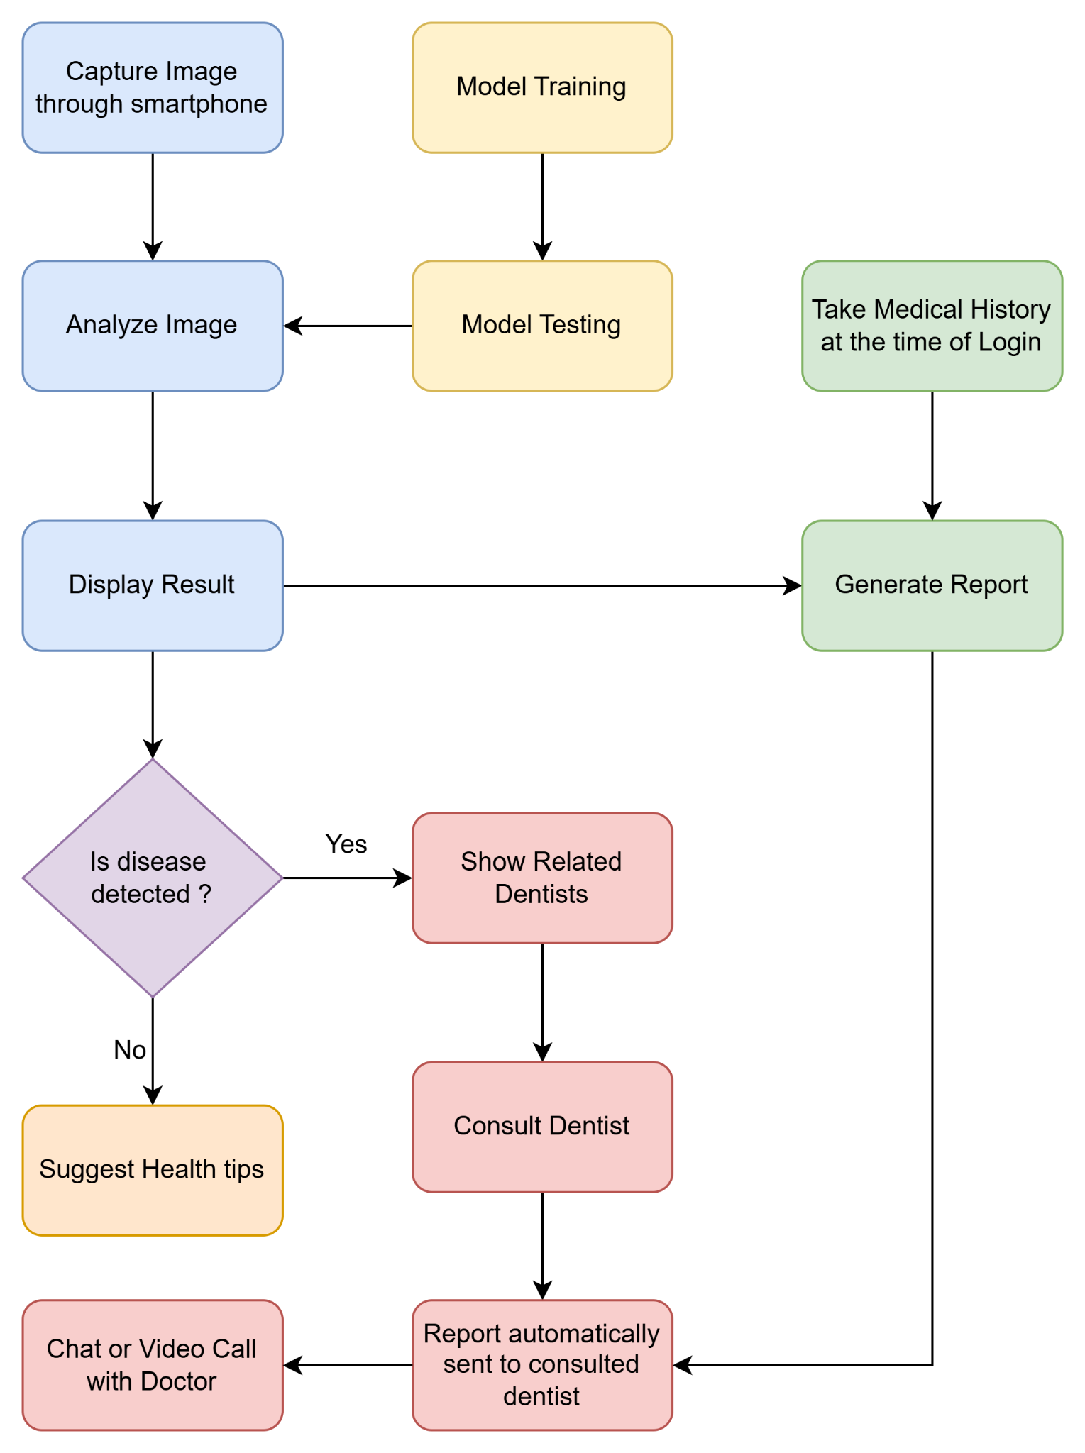

***Fig.4.1 Block Diagram of the System***

The block diagram outlines a system for detecting dental issues using smartphone images and machine learning. Users capture an image of their dental condition, which the system analyzes to identify anomalies through trained machine learning algorithms. Upon logging in, users provide their medical history, enhancing the context for image analysis. The trained model is tested for accuracy before implementation. After analysis, the system displays results indicating whether a disease is detected. If a disease is found, the system suggests related dentists; if not, it offers general dental health tips. Users can consult a selected dentist, and the system automatically sends a report of the findings and medical history to the dentist, facilitating early detection of dental issues and organized information flow.

## 4.2 Modular design of the system

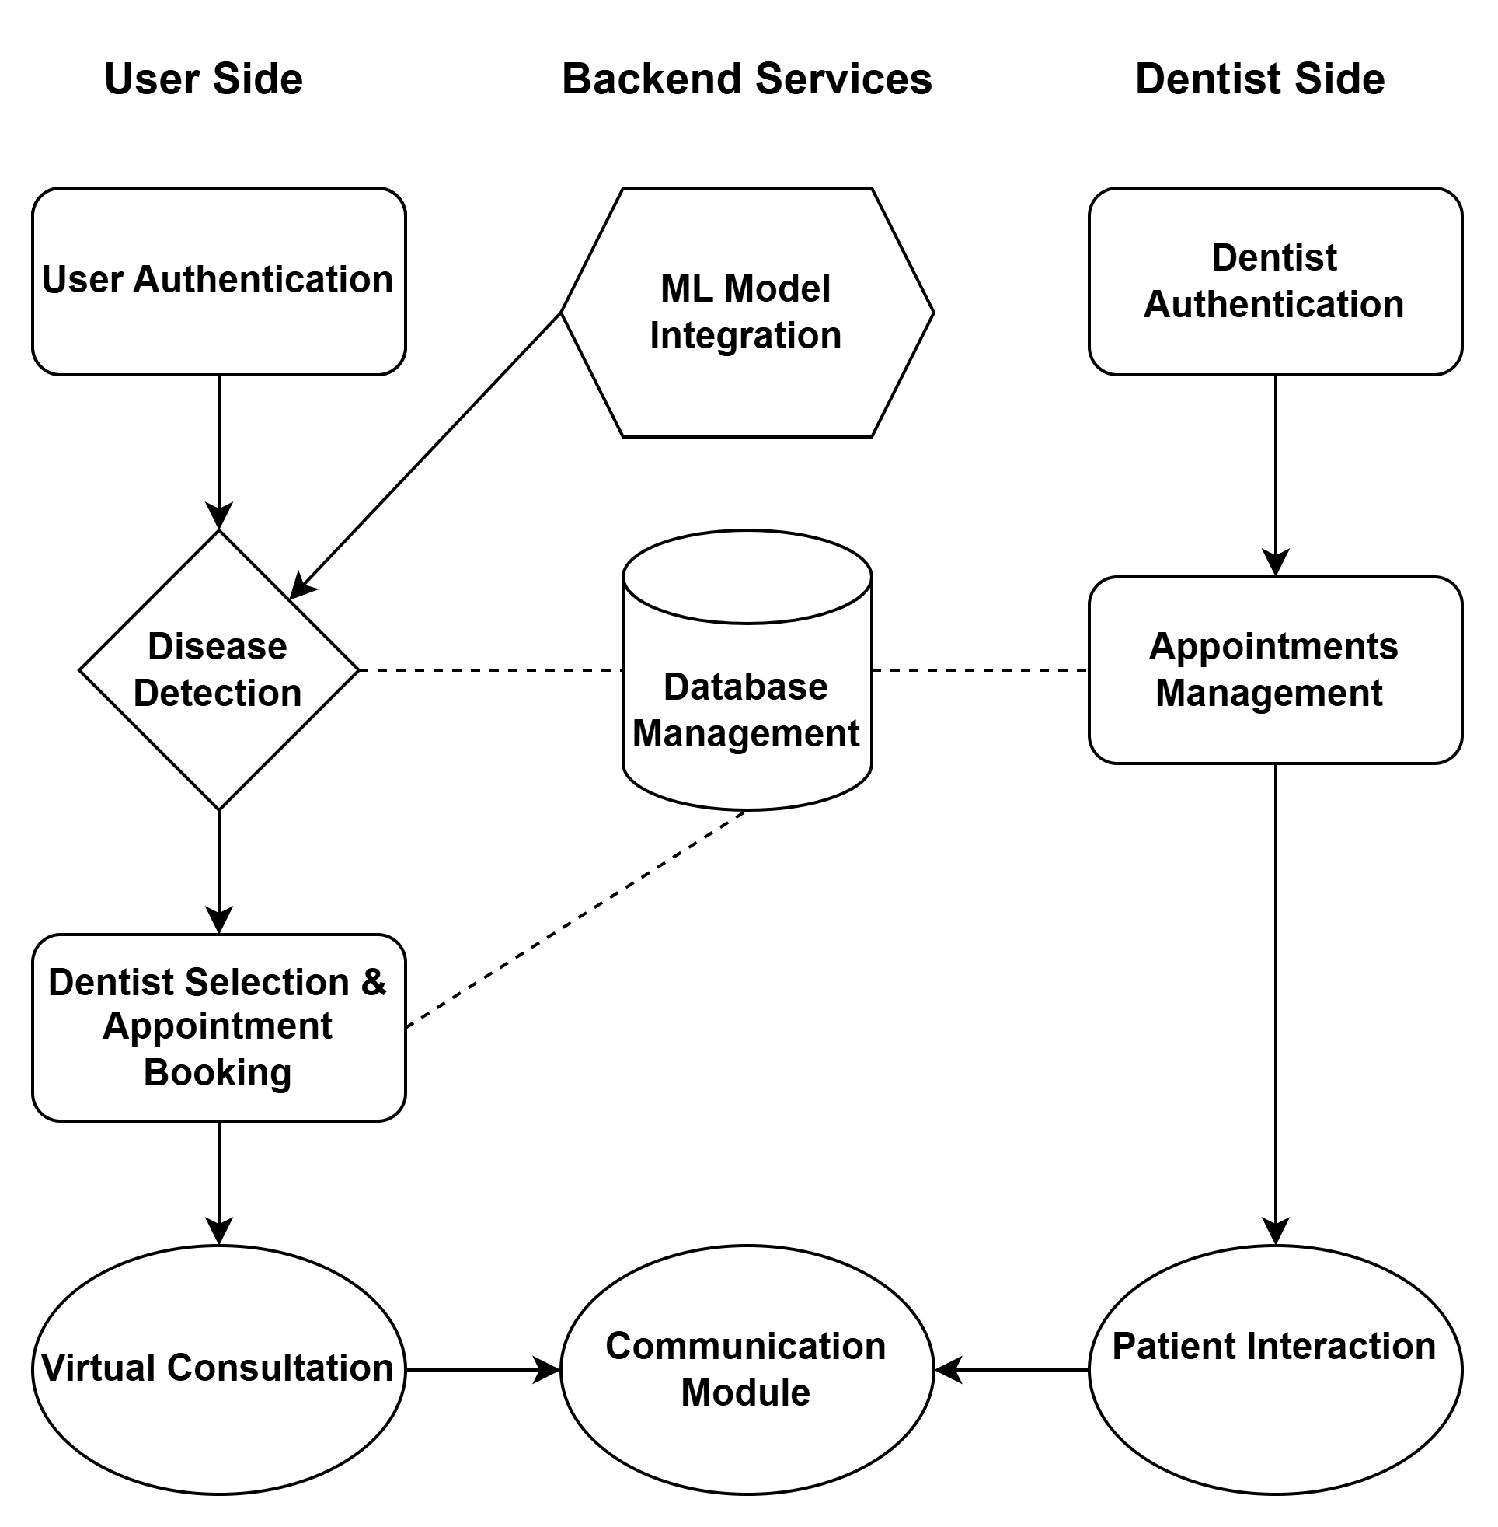

***Fig.4.2 Modular Diagram of the system***

The modular diagram of the ToothBuddy system illustrates the interaction between three core components: the User Side, Backend Services, and Dentist Side. On the User Side, patients begin by logging in through a secure authentication system and proceed to disease detection by uploading oral images, which are analyzed via the integrated ML model (YOLOv11) on the backend. Once a disease is detected, users can select a dentist and book an appointment. The Backend Services manage critical operations including ML model execution and database storage, ensuring smooth data flow between modules. Dentist selection and consultation details are stored in the database, enabling communication and appointment tracking. On the Dentist Side, authenticated dentists can access appointment management tools and patient data for review and interaction. The final phase involves virtual consultations, supported by a communication module that bridges the patient and dentist in real-time through chat or video call, ensuring seamless and personalized care delivery.

## 4.3 Detailed Design

### 4.3.1. DFD Level 0

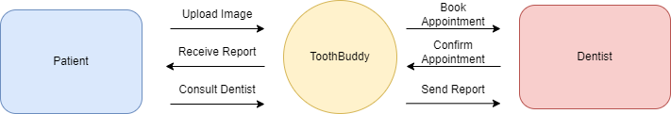

***Fig. 4.3 DFD Level 0***

The Level 0 Data Flow Diagram (DFD) provides a high-level overview of the ToothBuddy system, showing data flows between the main components: Patient, ToothBuddy, and Dentist. Patients upload images of their dental conditions to ToothBuddy, receive analysis reports, and can consult with dentists through the system. ToothBuddy processes these images and sends the generated reports to dentists, who can then confirm appointments. Serving as an intermediary, ToothBuddy facilitates communication and interaction between patients and dentists, streamlining the dental diagnostic process.

### 4.3.2 DFD Level 1

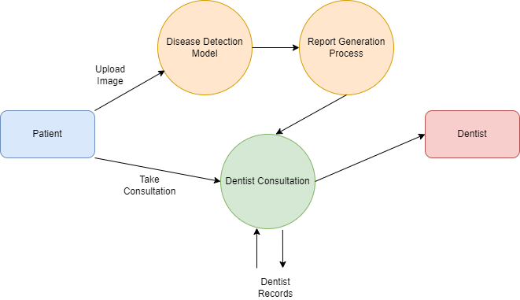

***Fig 4.4 DFD Level 1***

The Level 1 Data Flow Diagram (DFD) illustrates the data movement within a dentist consultation system, highlighting interactions among the Patient, Disease Detection Model, Report Generation Process, Dentist Consultation, and Dentist. Patients upload images for disease detection, which the Disease Detection Model analyzes using AI to identify dental issues. The findings are then sent to the Report Generation Process, which creates a report to assist in the dentist's consultation. During this central consultation process, dentists review the report and patient records to provide insights and treatment recommendations. This DFD emphasizes the seamless flow of data and processes aimed at enhancing dental care through automated disease detection and effective dentist consultations.

### 4.3.3 DFD Level 2

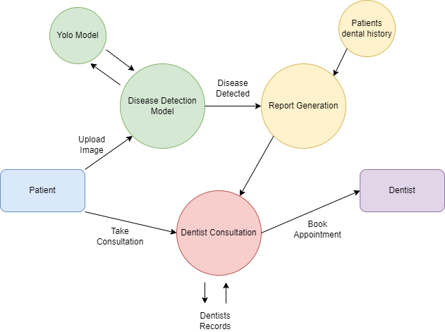

***Fig 4.5 DFD Level 2***

The Level 2 Data Flow Diagram (DFD) offers a detailed perspective on the dentist consultation system, highlighting components like the Patient, YOLO Model, Disease Detection Model, Report Generation, Patients Dental History, Dentist Consultation, and Dentist. Patients upload images of their dental conditions, which are processed by the YOLO Model for real-time object detection before being analyzed by the Disease Detection Model to identify any dental issues. The findings inform the Report Generation process, which creates a comprehensive report incorporating the patient's dental history. This report is then sent to the Dentist and used during the Dentist Consultation, where the dentist reviews all relevant information to provide accurate advice and schedule appointments. The dentist's feedback and updates are then integrated back into the system. This DFD Level 2 elaborates on how the YOLO model enhances disease detection and the crucial role of historical data in informing consultations and treatment plans.

### 4.3.4 State transition diagram

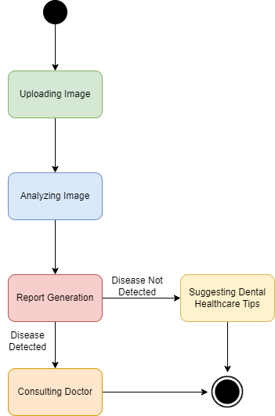

***Fig 4.6 State Transition Diagram***

The State Transition Diagram outlines the flow of a dental disease detection system, starting with the patient uploading an image of their dental condition. Following the upload, the system analyzes the image using a disease detection model, leading to report generation that summarizes whether a dental issue was found. If a disease is detected, the process directs the patient to consult with a dentist for further treatment. Conversely, if no issues are identified, the system suggests dental healthcare tips to promote good oral hygiene and prevent future problems. Overall, this diagram illustrates a clear process for efficiently detecting dental diseases and guiding patients toward appropriate next steps, whether that involves seeking professional help or receiving preventive advice.

### 4.3.5 ER Diagram

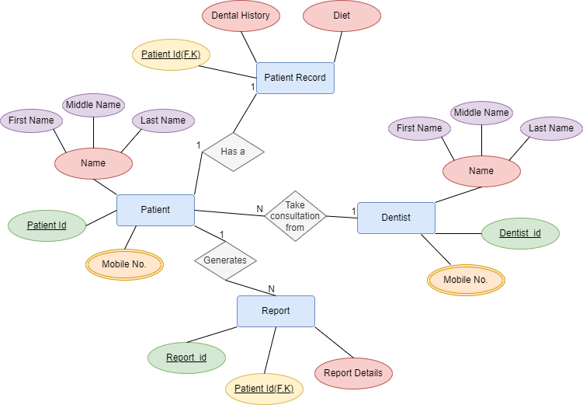

***Fig 4.7 ER Diagram***

The Entity-Relationship (ER) model for a dental clinic management system illustrates the relationships between key entities such as Patient, Patient Record, Dentist, and Report. The Patient entity includes attributes like Patient Id, names, and mobile number, establishing a one-to-one relationship with the Patient Record that contains dental history and dietary information. Each patient can consult multiple Dentists, while each dentist can treat numerous patients. The Report entity, linked to the Patient through a foreign key, captures detailed information about the patient's consultations, with each patient capable of generating multiple reports.

This model effectively captures the structure of a dental clinic's patient management system, highlighting how patients interact with records, consultations, and reports. It ensures that critical details about patient history, treatment consultations, and generated reports are well-organized and accessible, facilitating improved patient care and record-keeping.

## 4.4 Project Scheduling & Tracking using Timeline / Gantt Chart

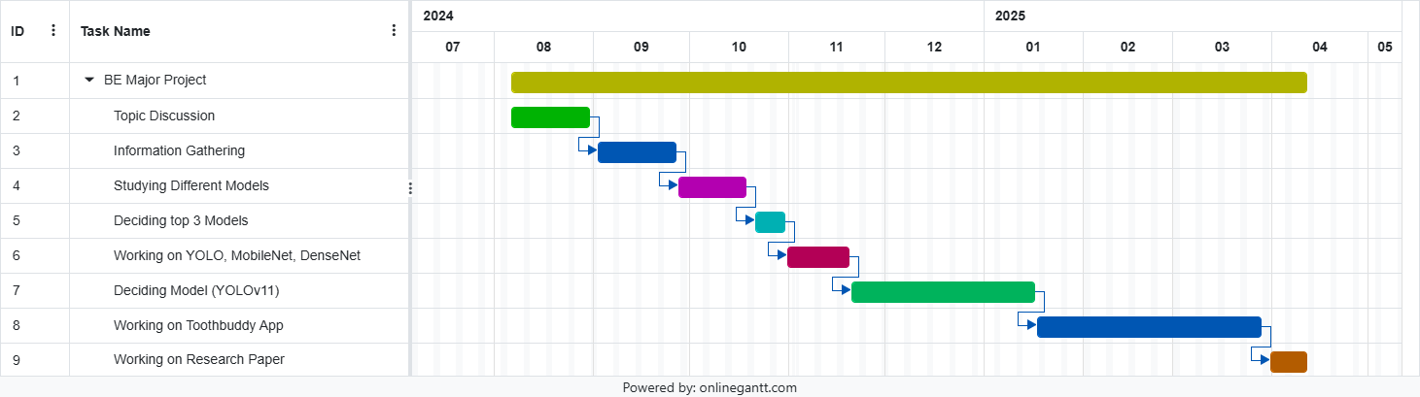

***Fig. 4.8 Gantt Chart***

The Gantt chart illustrates the structured timeline and progression of the BE Major Project titled "ToothBuddy," spanning from August 2024 to April 2025. It begins with the topic discussion phase in August, where the foundational idea of the project was conceptualized. This is followed by the information gathering stage in September and October, during which relevant data, research articles, and existing solutions were analyzed to understand the scope and feasibility of implementing AI in dental disease detection. In October and early November, a comparative study of different deep learning models was conducted, which helped in shortlisting the top three models: YOLO, MobileNet, and DenseNet. Subsequently, from mid-November to January 2025, these models were trained, tested, and evaluated. Based on performance metrics such as accuracy and inference time, YOLOv11 was finalized as the most effective model for integration into the mobile application.

With the model finalized, the development of the ToothBuddy mobile application began in January and continued until March 2025. This phase involved building the frontend using React Native and integrating backend services using Firebase, along with implementing real-time image processing and diagnosis features using YOLOv11. Following the development, the final phase of the project involved working on the research paper throughout March and early April 2025, documenting the methodologies, results, and contributions of the project.

# Chapter 5: Implementation of the Proposed System

## 5.1 Methodology Employed for Development

The development of the **ToothBuddy** system was structured using the **Agile development methodology**, which emphasizes adaptive planning, early delivery, and continuous improvement. This approach enabled the team to iteratively develop the platform while receiving feedback from end-users and domain experts—particularly a senior dentist—at each step. The system was logically divided into three major modules for seamless implementation and maintainability: **Patient-Side Mobile Application**, **Dentist-Side Application**, and the **Backend Services with Machine Learning Integration**.

#### **Key Development Phases:**

1. **Requirement Analysis and UI Planning**:  
    At the onset, comprehensive requirement analysis was carried out involving all stakeholders. Functional and non-functional specifications were documented after multiple brainstorming sessions and consultations. Based on this, low-fidelity wireframes and interactive mockups were designed for both the patient and dentist apps to visualize user navigation, ensure usability, and streamline the UI/UX workflow.
2. **Model Training and Testing**:  
    For the disease detection component, we employed **YOLOv11**, the latest version in the YOLO family optimized for faster and more precise detection of small objects such as lesions and discoloration in oral images. A custom dataset was curated and annotated, containing images of six diseases—**caries, gingivitis, ulcer, hypodontia, calculus, and tooth discoloration**. The model was trained using PyTorch, with key performance metrics such as **Precision, Recall, F1-Score**, and **mean Average Precision (mAP)** used to assess its efficacy.
3. **Mobile Application Development**:  
    Both the patient and dentist apps were developed using **React Native**, enabling cross-platform compatibility with a single codebase. Essential mobile features like **user authentication** (via Firebase), **camera access** (using react-native-camera), **real-time database** interaction, and **image uploading** to cloud storage were integrated. Special attention was paid to UI responsiveness and performance on lower-end devices.
4. **Integration of YOLOv11**:  
    The trained YOLOv11 model was converted to a lightweight, mobile-compatible format using **ONNX** or **TensorFlow Lite**, enabling real-time inference with minimal latency. The model was deployed via two approaches: (a) an API-based solution using **Flask or FastAPI**, where inference is performed on the server, and (b) an **on-device inference mode** for lower latency in future versions.
5. **Communication Features**:  
    To promote patient-dentist interaction, several real-time communication features were incorporated. A secure **chat module** was implemented using **Firebase Realtime Database**, while **video calling** capabilities were integrated using the **Agora SDK** and **WebRTC**. Furthermore, a basic **chatbot module** was built using Natural Language Processing (NLP) to respond to user queries and provide personalized oral hygiene tips.
6. **Testing and Optimization**:  
    The entire system underwent rigorous testing on multiple devices (both Android and iOS) to ensure performance, usability, and accuracy. Mobile responsiveness, image upload times, detection latency, and database sync rates were all monitored and optimized. Bugs were resolved in iterative cycles to refine user experience before deployment.

## 5.2 Algorithms and Flowcharts for the Respective Modules Developed

### A. YOLOv11 – Disease Detection Algorithm

The core detection algorithm of the ToothBuddy system is **YOLOv11 (You Only Look Once v11)**, an advanced object detection architecture that processes the entire image in a single forward pass. Unlike traditional methods that use region proposals, YOLO treats detection as a regression problem, enabling real-time performance ideal for mobile applications.

YOLOv11 is specifically optimized for detecting **small-scale anomalies** such as ulcers, lesions, and caries in oral cavity images. It improves upon previous versions with enhanced feature extraction modules and better spatial resolution, making it highly suitable for medical image analysis.

#### **YOLOv11 Disease Detection Workflow:**

1. **Image Division**:  
    The uploaded oral image is divided into an SxS grid where each grid cell is responsible for detecting objects whose center falls within it.
2. **Bounding Box Prediction**:  
    Each grid cell predicts multiple bounding boxes, along with associated confidence scores and class probabilities. Anchor boxes are used to better predict object shapes and scales.
3. **Class Prediction**:  
    For each bounding box, the model outputs a probability distribution over the possible classes (e.g., ulcer, caries, gingivitis, etc.).
4. **Non-Maximum Suppression (NMS)**:  
    To avoid multiple overlapping predictions, NMS is applied to retain only the bounding boxes with the highest confidence for each object class, thereby improving clarity.
5. **Output Results**:  
    The final output consists of bounding boxes around the detected region, labeled with the disease name and a confidence score.  
   **Pseudocode Representation:**

*for image in uploaded_images:*

*predictions = YOLOv11_model.predict(image)*

*for box in predictions:*

*if box.confidence > threshold:*

*draw_box_and_label(image, box)*

This algorithm is triggered once a user uploads an image. It processes the image through the YOLOv11 model and visualizes the detection results by overlaying the bounding box and label on the original image.

### B. Flowchart: Patient Image Detection & Report Generation

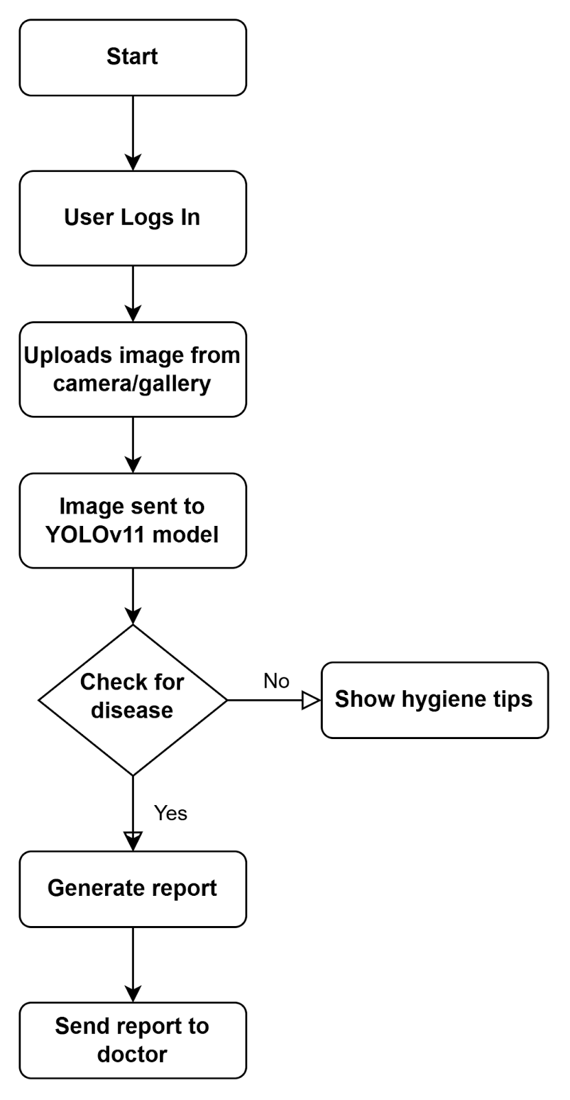

***Fig.5 .1 Flowchart of Patient App***

The flowchart outlines the step-by-step functioning of the Patient App within the ToothBuddy system. The process begins when the user launches the app and logs in using their credentials. After authentication, the user is prompted to upload an image of their oral cavity, either by capturing it using the device’s camera or selecting one from the gallery. This image is then forwarded to the backend where the YOLOv11 model performs disease detection. Based on the model's output, the system checks for any signs of oral disease. If no disease is detected, the app displays personalized oral hygiene tips to the user. However, if a disease is identified, a detailed diagnostic report is generated automatically. This report is then securely transmitted to the consulted dentist for further evaluation and follow-up. This streamlined workflow ensures early detection and seamless communication between the patient and the healthcare provider.

**C. Flowchart: Doctor Consultation Module**

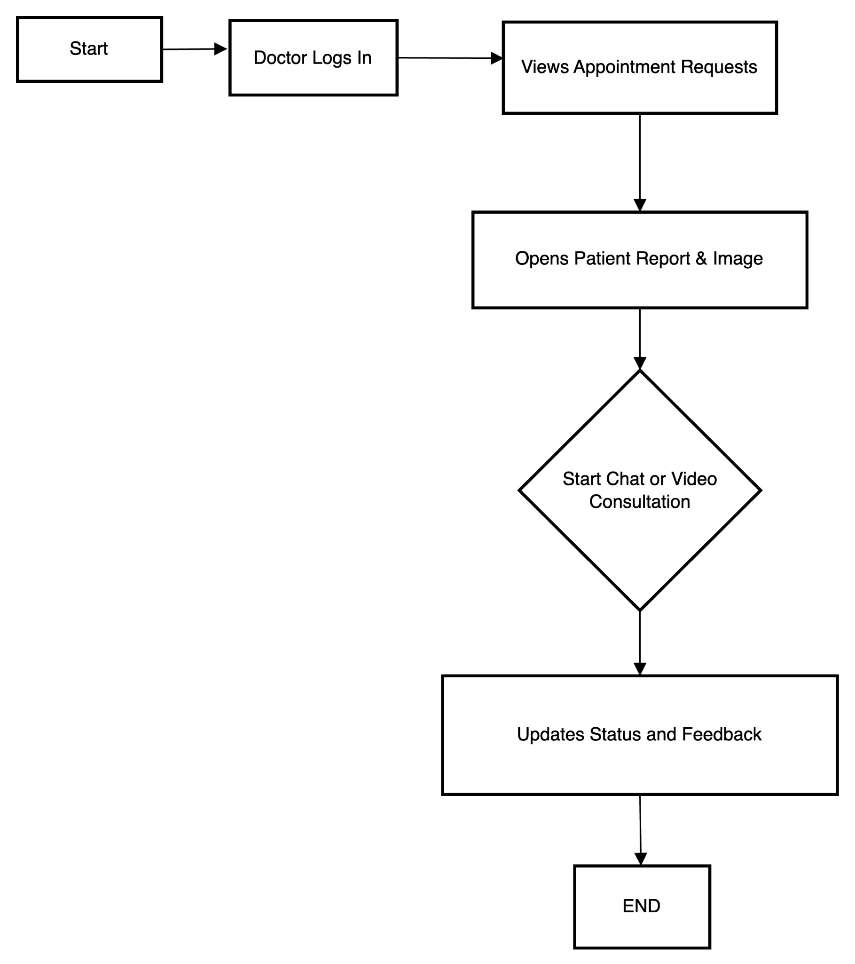

***Fig. 5.2 Flowchart of Doctor App***

The flowchart illustrates the operational flow of the Doctor App in the ToothBuddy system. The process begins when the doctor logs into the application using their credentials. Once authenticated, the doctor can view a list of appointment requests from patients. Upon selecting an appointment, the doctor gains access to the corresponding patient report and image, which were generated based on disease detection from the patient's uploaded image. After reviewing the diagnostic details, the doctor may choose to initiate a chat or video consultation with the patient for further discussion or clarification. Following the consultation, the doctor proceeds to update the status of the report and provide relevant feedback or treatment recommendations, thereby completing the consultation workflow. This structured approach ensures efficient and informed interaction between the healthcare provider and the patient.

### 5.3 Datasets source and utilization

The success of the disease detection model depends heavily on the dataset used for training. Our dataset was **custom-built** through image collection and annotation.

**Dataset Summary:**

| **Disease Type** | **No. of Images** | **Annotation Format** | **Source** |
| --- | --- | --- | --- |
| Caries | 700+ | YOLO TXT | Clinical images, Web |
| Ulcer | 700+ | YOLO TXT | Public datasets, Web |
| Gingivitis | 700+ | YOLO TXT | Manual dataset |
| Calculus | 700+ | YOLO TXT | Collected from Web |
| Tooth Discoloration | 700+ | YOLO TXT | Public sources |

***Table 5.1 Dataset summary***

**Annotation Tool Used:**The image annotation process was carried out using **LabelImg**, an open-source graphical image annotation tool. This tool was selected for its ease of use and compatibility with the YOLO format. Each image was carefully labeled by drawing bounding boxes around regions affected by oral diseases and assigning the appropriate class label. The output was saved in the **YOLO TXT format**, which includes the class index and normalized bounding box coordinates—essential for object detection tasks.

**Data Organization:**To maintain consistency and streamline the training process, the dataset was organized into separate folders:

* */images/train, /images/val, /images/test:* These directories contain the training, validation, and testing images respectively.
* */labels/train, /labels/val, /labels/test:* Corresponding directories that hold the annotation files (in YOLO TXT format) for each image set.

Additionally, a data.yaml file was created to define the dataset structure for YOLOv11. This file specifies the paths to the training and validation data, along with the list of class names such as caries, ulcer, gingivitis, calculus, and tooth discoloration.

**Utilization in Training:**The annotated dataset was used for **supervised training** of the YOLOv11 model. The training process was executed using **PyTorch**, a popular deep learning framework. To handle the computational load and accelerate the training, the process was carried out on **Google Colab**, which provides access to **GPU acceleration**. This not only improved training speed but also allowed for multiple epochs and hyperparameter tuning without local hardware limitations.

**Model Evaluation:** To assess the model’s effectiveness in detecting oral diseases, a set of standard object detection metrics was employed:

* **Precision**: Measures the accuracy of positive predictions, indicating how many detected diseases were actually correct.
* **Recall**: Assesses the model's ability to identify all relevant disease cases from the dataset.
* **Mean Average Precision (mAP)**: Provides a balanced evaluation by combining precision and recall across various confidence thresholds. It is considered the most comprehensive metric for object detection performance.
* These metrics collectively provided a detailed understanding of the model’s reliability and accuracy in real-world diagnostic scenarios.

# Chapter 6: Testing of the Proposed System

## 6.1. Introduction to Testing

The testing phase was a crucial step in validating the effectiveness, efficiency, and reliability of the ToothBuddy system. It focused on analyzing the performance of three distinct deep learning models—**YOLOv11**, **MobileNetV2**, and **DenseNet**—used for identifying and classifying dental diseases from oral images. Each model was tested under multiple conditions to evaluate its real-world applicability, especially when deployed on mobile devices. Emphasis was placed on assessing not just accuracy but also the **computational load**, **response time**, and **integration capabilities** with the mobile application to ensure seamless user experience. The testing also helped identify the most suitable model for specific disease types and functionalities based on their strengths.

## 6.2. Types of Tests Considered

To comprehensively evaluate the system, multiple types of tests were conducted:

* **Model Performance Tests**: Each model was evaluated on its ability to detect and classify five types of oral conditions—**caries, calculus, hypodontia, ulcers, and gingivitis**. Metrics such as precision, recall, and accuracy were used to rank the models.
* **Real-time Deployment Testing**: The trained models were deployed into the mobile app, and their ability to handle real-time image input from the camera or gallery was tested. This involved checking for inference speed, memory usage, and response time.
* **Cross-platform Functionality**: Since the app was built using **React Native**, testing was carried out on both **Android and iOS** platforms to ensure UI consistency, API responsiveness, and model compatibility across devices.
* **Consultation Module Testing**: Integration of third-party services like **Jitsi Meet** for video calls and **Firebase** for authentication and appointment scheduling was tested under various network conditions. This was essential to guarantee reliability in virtual consultations.

## 6.3. Various Test Case Scenarios Considered

A range of real-world scenarios was designed to test different functionalities and use cases of the system:

* **Disease-specific Image Classification**: Individual disease detection capabilities were tested—for instance, DenseNet was specifically evaluated for ulcer identification, given its performance in subtle feature extraction.
* **Real-time Scanning and Feedback**: Simulated use cases where patients used the app to scan their oral cavity and receive immediate detection results were assessed. Latency, accuracy, and feedback clarity were important metrics.
* **Remote Consultation Booking**: Test cases included booking appointments from rural and urban locations, checking for network-related issues, and verifying whether the scheduling system remained responsive and accurate.
* **Chatbot Evaluation**: The in-app chatbot was tested for its ability to respond to common oral health queries, including first-aid suggestions, hygiene tips, and follow-up advice. Testers rated the relevance and clarity of responses.
* **Dentist Interface Testing**: Functionality on the dentist’s side was tested, such as viewing scheduled appointments, accessing reports, and initiating consultations. The process of updating consultation status and patient feedback was also evaluated.

## 6.4. Inference Drawn from the Test Cases

From the extensive testing process, several important insights were gathered:

* **YOLOv11** emerged as the most effective model for **real-time object detection**, achieving a remarkable **accuracy of 92%**. Its speed and precision made it ideal for live disease identification through camera input.
* **MobileNetV2** demonstrated a strong balance between **speed and classification accuracy (67%)**, making it suitable for general disease screening on mobile platforms with limited computational power.
* **DenseNet**, although having a lower overall accuracy of **57%**, showed **notable strength in detecting fine-grained features**, particularly useful in identifying **ulcers**, where subtle texture changes are key.
* The **combined use** of these models—YOLOv11 for localization and MobileNetV2/DenseNet for classification—significantly enhanced the **overall diagnostic capability**, ensuring both high-speed and high-accuracy results.
* The **consultation features** integrated into the app, including video calling and real-time messaging, were found to be **robust and user-friendly**, thereby improving doctor-patient communication.
* Overall, the system was deemed reliable for real-world deployment, showing strong potential in delivering **accessible, AI-driven dental diagnostics and care** through a mobile platform.

# Chapter 7: Results and Discussion

**7.1. Screenshots of User Interface (UI) for the respective module**

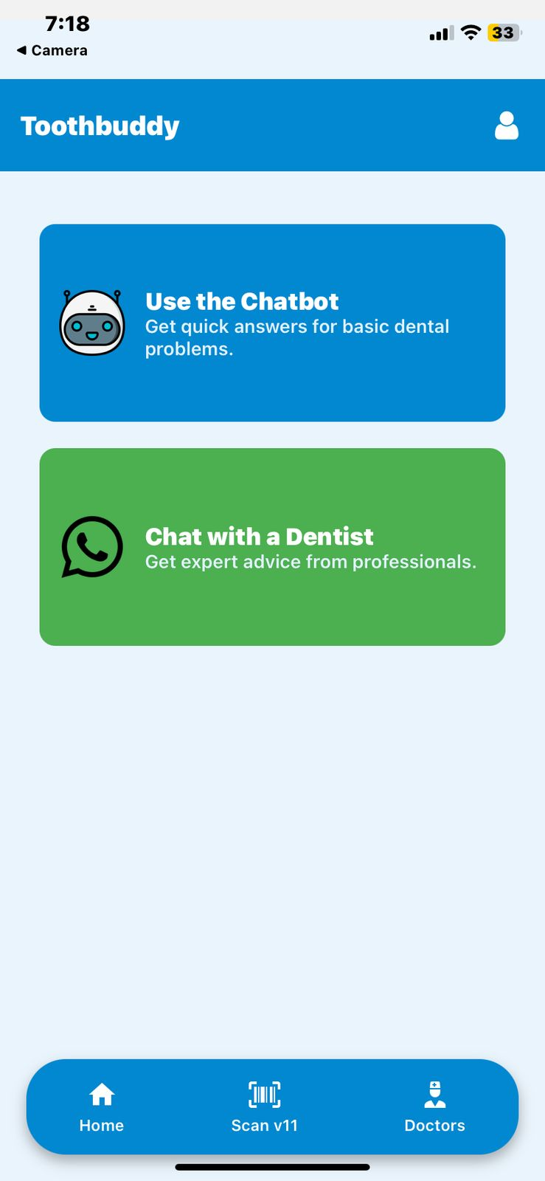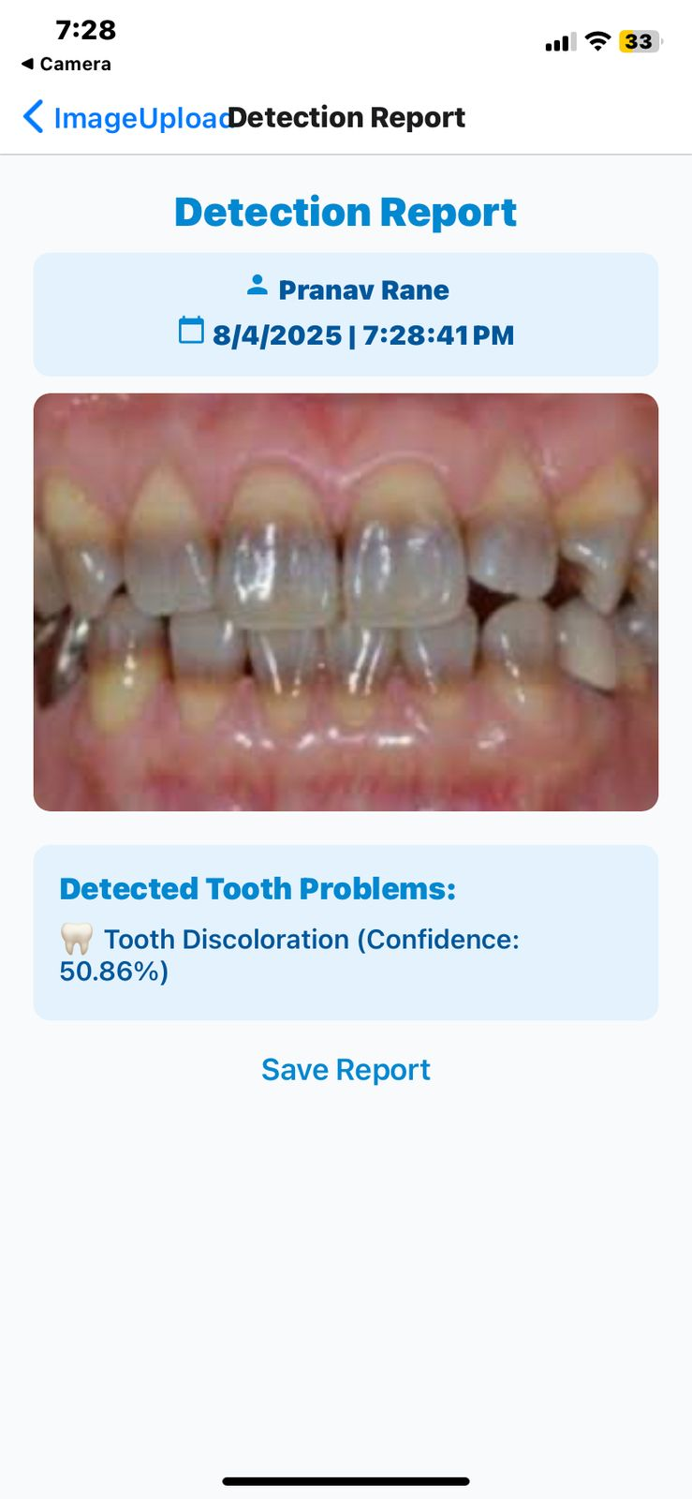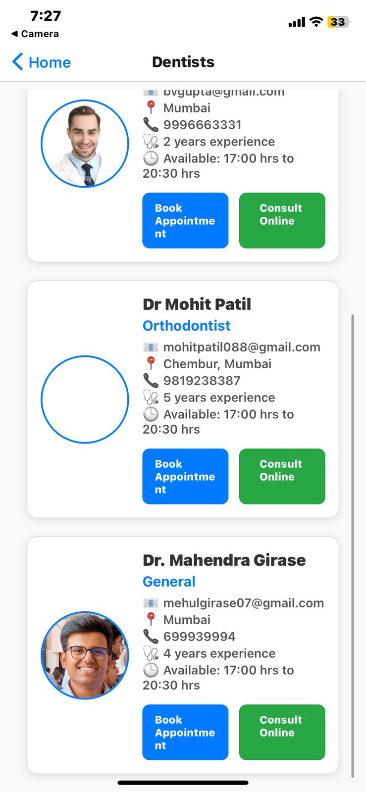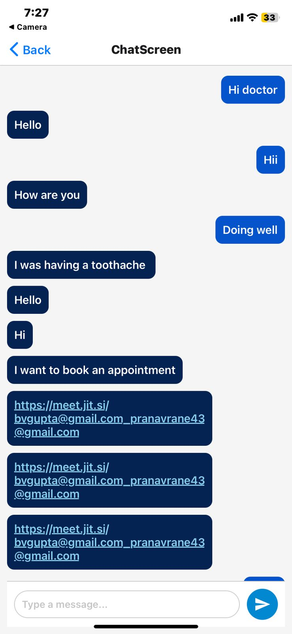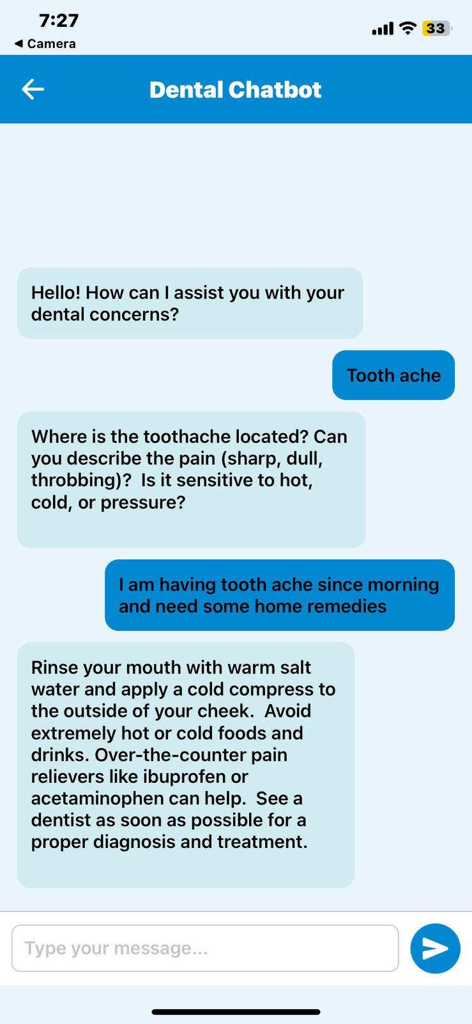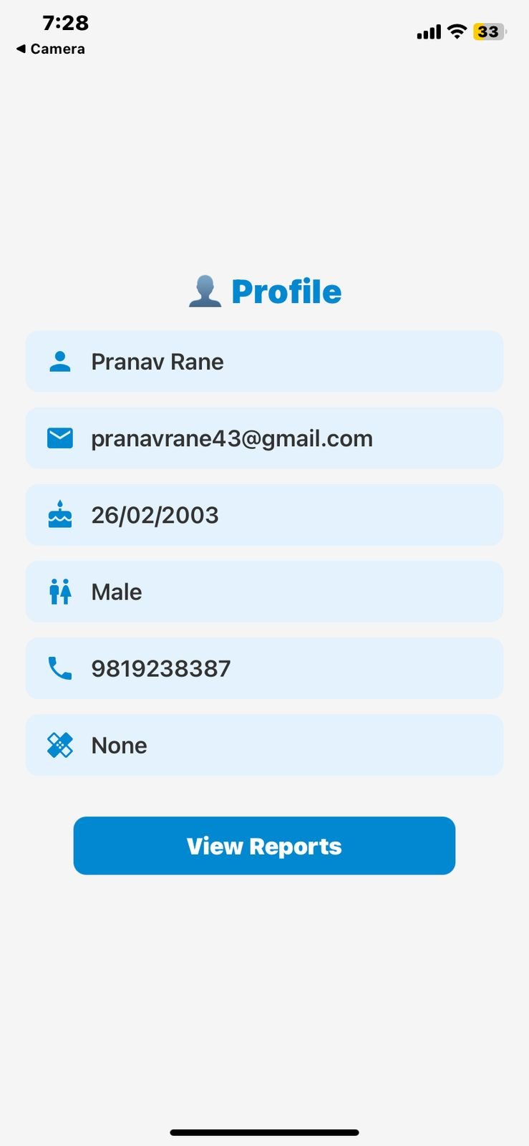

***Fig. 7.1 Patients App***

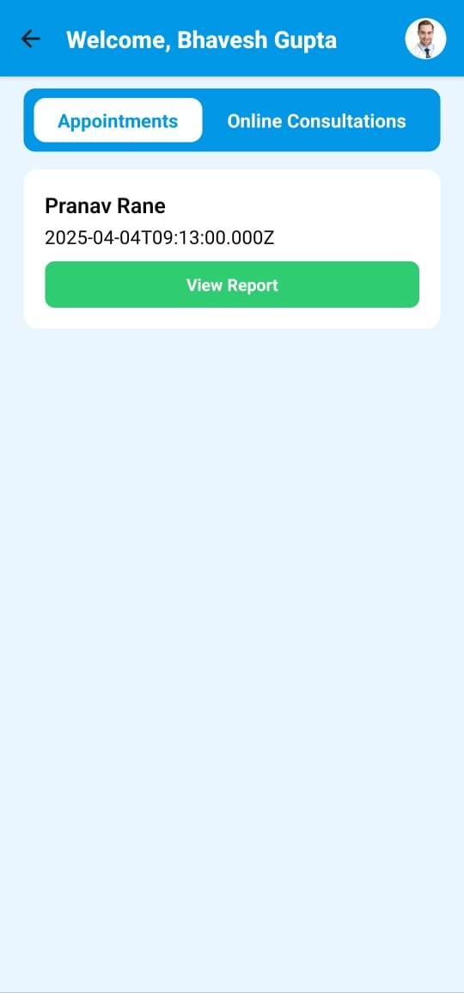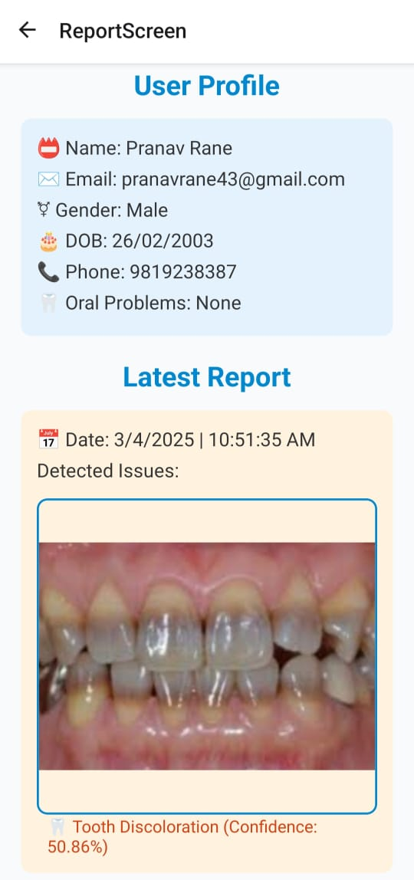 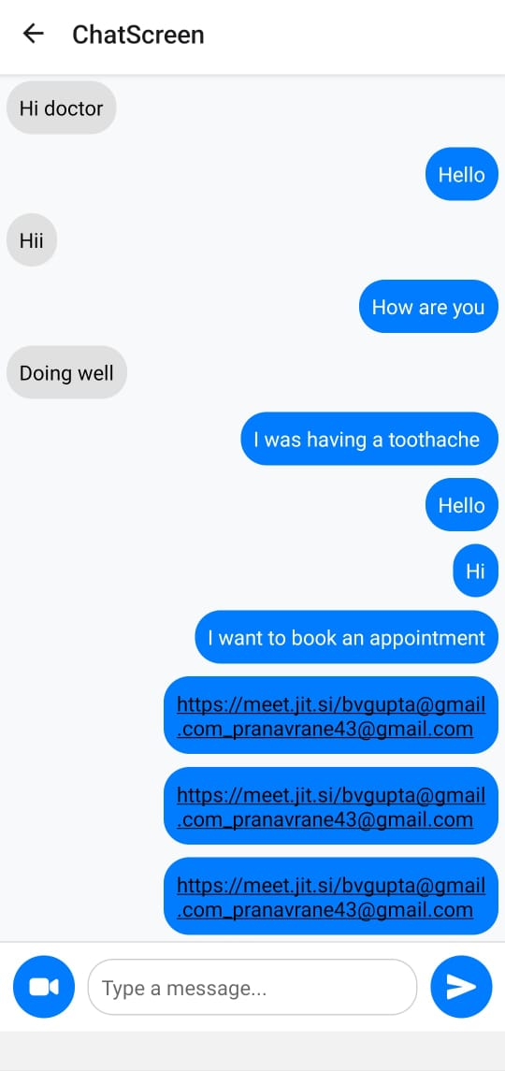

***Fig. 7.2 Dentists App***

## 7.2. Performance Evaluation Measures

The performance of the disease detection models—YOLOv11, MobileNetV2, and DenseNet—was evaluated using standard machine learning metrics, focusing on accuracy, inference speed, and real-world deployability. The table below summarizes the accuracy of each model:

| **Model** | **Accuracy** |
| --- | --- |
| YOLOv11 | 92% |
| MobileNetV2 | 67% |
| DenseNet | 57% |

***Table 7.1 Model Comparison***

Additional performance indicators used in the evaluation include:

* **Accuracy**: Proportion of correct predictions out of the total number of cases tested.
* **Precision and Recall**: Although not explicitly calculated for each class, these were implied in the evaluation of how well each model identified disease presence versus false positives.
* **Inference Time**: Time taken by the model to produce an output after receiving the input image, particularly important in mobile applications where responsiveness is key.
* **Confidence Score Threshold**: A threshold of 0.5 was used to determine the classification label. Only predictions with confidence greater than or equal to 50% were considered valid, which helped in reducing misclassifications.

### 

## 7.3. Input Parameters / Features Considered

The models were trained and evaluated using specific preprocessed image features tailored for each architecture:

* **Preprocessing Techniques**:
  + Images were resized, normalized (pixel values scaled), and augmented using techniques like rotation, flipping, and brightness variation to increase dataset diversity.
* **Target Diseases**:
  + The models were trained to recognize **five key dental conditions**: *caries, calculus, hypodontia, ulcers,* and *gingivitis*.
* **Input Image Dimensions**:
  + **MobileNetV2 and DenseNet**: 224 × 224 pixels, matching their default input layer configurations.
  + **YOLOv11**: 416 × 416 pixels, as per YOLO’s object detection input requirement to ensure finer spatial resolution for bounding box predictions.

## 7.4. Graphical and Statistical Output

Each model generated distinct types of outputs suited to its architecture:

* **YOLOv11**:
  + Output included **bounding boxes**, **class labels**, and **confidence scores** drawn directly on the input images.
  + The graphical result allows users to visually identify the exact region affected by a particular disease.
* **MobileNetV2 and DenseNet**:
  + These models output **softmax probability vectors** across all disease categories, with the highest probability determining the predicted disease.
  + Statistical outputs were displayed in a user-friendly format, showing the most probable disease label and associated confidence level.
* **Generated Reports**:
  + Reports included: Input Image, Detected Disease, Confidence Score, Detection Time (in seconds), and Health Recommendations.
  + These were stored in Firebase and shared with dentists for consultation.

## 7.5. Comparison of Results with Existing Systems

ToothBuddy’s performance was benchmarked against existing AI-based oral diagnostic systems:

* **Smart R-CNN**:
  + While known for high accuracy, it suffered from **slower inference speed**, making it less suitable for real-time mobile applications. ToothBuddy’s YOLOv11-based pipeline surpassed it with significantly faster detection.
* **iGAM and AICaries**:
  + Web-based platforms like AICaries offered basic classification models for caries but lacked multi-disease detection and real-time capabilities. ToothBuddy introduced a **more comprehensive, mobile-first solution**.
  + Our models outperformed these in **early detection precision** and had better deployment feasibility thanks to their **lightweight architecture**.
* **Traditional Diagnosis**:
  + In many rural or under-resourced settings, early diagnosis is often missed due to lack of access to professional dental tools. ToothBuddy bridges this gap by offering **instant disease detection** using only a smartphone camera.

## 7.6. Inference Drawn

From the performance analysis and test evaluations, several key inferences were made:

* **YOLOv11** proved to be the most efficient and accurate model, achieving **real-time detection** with 92% accuracy and low inference latency. It is ideal for mobile-based live detection where speed and responsiveness are crucial.
* **Model Combination Strategy**: Utilizing **DenseNet** for subtle conditions like **ulcers** enhanced reliability in edge cases, while **MobileNetV2** maintained a balance between resource usage and classification performance, especially for broader disease recognition.
* **System Synergy**: The integration of all three models in the ToothBuddy app ensures a **well-rounded diagnostic approach**. YOLOv11 handles object detection, MobileNetV2 offers fast classification, and DenseNet focuses on nuanced diagnosis, making the platform adaptable and robust.
* **Enhanced Accessibility**: The app's deployment on mobile devices, along with cloud-backed storage and real-time consultation features, improves **accessibility to dental care** for populations lacking immediate access to professionals.  
  **Scalability and Flexibility**: The architecture is lightweight and modular, making it highly scalable and easy to update. New diseases or model improvements can be integrated without overhauling the entire system.
* In conclusion, the ToothBuddy platform successfully merges deep learning with mobile technology to provide **accurate, fast, and accessible oral disease diagnosis**, paving the way for **AI-powered tele-dentistry**.

# Chapter 8: Conclusion

## 8.1 Limitations

Despite the promising results and overall system functionality, there are certain limitations that must be acknowledged, both in terms of technical constraints and practical challenges during deployment:

* **Dataset Limitations**: The current dataset, although sufficient for initial training and evaluation, is restricted in diversity. The number of annotated images per disease is relatively limited, and certain conditions such as rare anomalies or early-stage symptoms are underrepresented. Including a broader set of annotated dental diseases—such as oral cancer, cysts, or developmental anomalies—could significantly improve the generalizability and robustness of the model in real-world scenarios.
* **Model-Specific Constraints**: DenseNet, which was used particularly for ulcer detection, demonstrated only moderate accuracy compared to YOLOv11. Its lower performance in identifying ulcers, which can have subtle or varying visual patterns, suggests that additional model tuning, architecture optimization, or training on a more diverse dataset is necessary.
* **Mobile Device Limitations**: Although YOLOv11 was optimized for mobile deployment, devices with limited processing power, lower RAM, or older chipsets may still experience latency, frame drops, or overheating during real-time inference. This can affect the app’s responsiveness and user experience on budget or older smartphones.
* **Environmental Dependency**: The system’s detection accuracy is highly dependent on external factors such as lighting conditions, image resolution, and camera focus. Poor lighting, motion blur, or improper camera angles can reduce the effectiveness of disease detection. Ensuring consistent image quality from various users remains a challenge.

## 8.2 Conclusion

This project demonstrates the feasibility and effectiveness of integrating deep learning models into a mobile-based diagnostic system for oral healthcare. The primary goal was to evaluate and deploy models capable of accurately detecting and classifying common dental diseases from user-submitted images in real-time. Through comparative analysis, **YOLOv11** emerged as the most suitable model due to its superior accuracy (92%), minimal inference time, and ability to detect multiple diseases from a single frame.

Among the tested models—MobileNetV2, DenseNet, and YOLOv11—YOLO proved the best fit for real-time mobile applications, offering a reliable solution that balances performance and efficiency. MobileNetV2 was ideal for lightweight classification tasks, while DenseNet contributed value in detecting certain subtle conditions like ulcers despite its lower overall accuracy.

The **ToothBuddy** application successfully bridges the gap between artificial intelligence-based diagnosis and accessible, real-world oral healthcare services. With a user-friendly interface, patients can capture oral images, receive immediate diagnostic feedback, and access detailed health reports that include disease classification, prediction confidence, time, and personalized tips. The application further enables users to consult a dentist virtually through **chat or video conferencing**, powered by tools like Jitsi Meet.

On the dentist’s side, the platform simplifies case management, providing a dedicated interface to review incoming reports, schedule appointments, and interact with patients seamlessly. Built using React Native and backed by Firebase, the system ensures robust performance, cross-platform compatibility, and real-time data handling, thereby enabling smooth collaboration between patients and healthcare providers.

## 8.3 Future Scope

While the current implementation provides a solid foundation, several avenues exist to further enhance the system’s capabilities and expand its impact in the future:

* **Model Optimization**: Advanced techniques like **quantization**, **pruning**, and **knowledge distillation** can be employed to make the models lighter and faster without sacrificing accuracy. This would improve performance on entry-level smartphones and reduce energy consumption during inference.
* **Expanded Dataset Collection**: Incorporating more diverse and rare dental conditions into the dataset can improve the model’s adaptability to real-world cases. Partnering with dental hospitals, clinics, and academic institutions can facilitate the acquisition of more annotated images with verified diagnoses.
* **On-device Inference**: Currently, the system supports both backend and optional on-device inference. Enhancing on-device capabilities through tools like TensorFlow Lite and CoreML could allow full offline functionality, which is essential for remote or rural areas with limited internet access.
* **Integration with EHR Systems**: Future versions of ToothBuddy could include integration with **Electronic Health Records (EHR)** for seamless transfer of patient data, improving continuity of care and enabling long-term tracking of oral health.
* **Multilingual and Accessibility Support**: Adding language support for regional users and accessibility features like **voice-guided navigation** or **screen readers** can make the app more inclusive for diverse user groups, including visually impaired individuals.
* **Regulatory Compliance and Validation**: As the system moves closer to clinical use, rigorous validation under regulatory frameworks such as **HIPAA**, **GDPR**, and **CDSCO** will be required. Clinical trials and collaboration with healthcare authorities could help gain certifications and trust for deployment in formal healthcare settings.

In summary, ToothBuddy represents a pioneering step toward AI-assisted oral healthcare that is mobile, efficient, and user-centric. By combining cutting-edge computer vision techniques with intuitive design and communication tools, it has the potential to revolutionize early dental disease detection and improve access to expert care for patients worldwide.

# References

[1]Mohandas, Dr.R. & Sundareswaran, Veena & Reddy, K. & Yaswanth, C. & Jaswanth, N.. (2023). An Intelligent System for Dental Disease Detection Using Smart R-CNN Technique. Migration Letters. 20. 341-347. 10.59670/ml.v20iS13.6464.

[2] Tobias, Guy & Spanier, Assaf. (2020). Developing a Mobile App (iGAM) to Promote Gingival Health by Professional Monitoring of Dental Selfies: User-Centered Design Approach. JMIR mhealth and uhealth.

[3] Xiao, Jin & Luo, Jiebo & Ly-Mapes, Oriana & Wu, Tong & Dye, Timothy & Jallad, Nisreen & Hao, Peirong & Ruan, Jinlong & Bullock, Sherita & Fiscella, Kevin. (2021). Assess A Smartphone App (AICaries) that uses artificial intelligence to detect dental caries in children and provide interactive oral health education: Protocol for design and usability testing (Preprint). JMIR Research Protocols. 10. 10.2196/32921.

[4]Anantharaman, Rajaram & Velazquez, Matthew & Lee, Yugyung. (2018). Utilizing Mask R-CNN for Detection and Segmentation of Oral Diseases. 2197-2204. 10.1109/BIBM.2018.8621112.

[5] Liu, Lizheng & Xu, Jiawei & Huan, Yuxiang & Zou, Zhuo & Yeh, Shih-Ching & Zheng, Lirong. (2019). A Smart Dental Health-IoT Platform Based on Intelligent Hardware, Deep Learning and Mobile Terminal. IEEE journal of biomedical and health informatics. PP. 10.1109/JBHI.2019.2919916.

[6] Väyrynen, Elina & Hakola, Sanna & Keski-Salmi, Anniina & Jämsä, Hanna-Leena & Vainionpää, Raija & Karki, Saujanya. (2023). The Use of Patient-Oriented Mobile Phone Applications in Oral Health: A Scoping Review. JMIR mhealth and uhealth. 11. 10.2196/46143.

[7]Safaldin, M., Zaghden, N., & Mejdoub, M. (2024). An improved YOLOv8 to detect moving objects. *IEEE Access*.

[8]Ali, M. A., Fujita, D., & Kobashi, S. (2023). Teeth and prostheses detection in dental panoramic X-rays using CNN-based object detector and a priori knowledge-based algorithm. *Scientific Reports*, *13*(1), 16542.

[9] Thulaseedharan, A., & PS, L. P. (2022, November). Deep learning based object detection algorithm for the detection of dental diseases and differential treatments. In *2022 IEEE 19th India Council International Conference (INDICON)* (pp. 1-7). IEEE.

[10] Lian, L., Zhu, T., Zhu, F., & Zhu, H. (2021). Deep learning for caries detection and classification. *Diagnostics*, *11*(9), 1672.

# Appendix

**1. Paper I details**

**a. Research Paper**

# **ToothBuddy : Remote Dental Diagnostic and Consultation System**

**Prof. Mannat Doultani$, Mohit Patil#, , Mahendra Girase#, Pranav Rane#, Amisha Chandwani#**

$: Assistant Professor, Computer Engineering Department , Vivekanand Education Society’s Institute of Technology, Mumbai

#: Student in Computer Engg. Vivekanand Education Society’s Institute of Technology, Mumbai

**Abstract:**

Oral health problems tend to go unnoticed due to inadequate routine checks, despite oral health being at the center of an individual's health. This research study introduces different deep learning models with the objective of developing an efficient automated system for the external diagnosis of oral diseases using machine learning-based classification methods. A comparative analysis is carried out in terms of accuracy, computational complexity, and real-time applicability of models such as MobileNet, DenseNet, and YOLO. Based on this comparison, the most efficient model is implemented in the ToothBuddy mobile app, which uses smartphone cameras to enable mouth scans and provide diagnostic feedback. In addition, the app simplifies the scheduling of dental appointments and enables online consultations via chat and video calls, thus enabling a smooth interaction between patients and healthcare professionals. Through the comparative analysis of deep learning methods, this research determines the most suitable model for the classification of oral diseases with high accuracy and low computational complexity. The results of this study validate the feasibility of AI-based dental diagnostics to improve accessibility and enable early detection of common oral health problems.

**Keywords: ToothBuddy, oral disease detection, machine learning, mHealth, YOLO, MobileNetV2, DenseNet, dental image analysis, caries detection, gingivitis detection, ulcer detection, hypodontia detection, calculus detection, AI in dentistry, real-time disease detection, mobile-based diagnosis, accessibility to healthcare, preventive dental care, image-based diagnostic, smartphone use in healthcare.**

**Introduction:**

Early detection of oral diseases is necessary to prevent serious dental problems. Traditional diagnosis is dependent on expert opinions, which are not easily accessible in rural or developing regions. With the advent of deep learning recently, computerized image-based diagnostic systems are now possible for primary oral disease detection. This study compares various CNN architectures—MobileNet, DenseNet and YOLO—for disorder classification such as calculus, hypodontia, gingivitis, caries, mouth ulcers, and tooth discoloration.

The ToothBuddy mobile app integrates the best model according to these comparison studies. Individuals can capture dental images using their phones and receive immediate diagnostic feedback. From the outcome, users can book appointments and avail themselves of online consultations via chat and video conferencing, thus ensuring easy communication with dental professionals.

The research targets the most accurate, light-weight, and effective model, driving scalable and accessible AI-based dental diagnostics worldwide. These results are deployed in the ToothBuddy mobile app, acting as an effective tool for early detection, scheduling appointments, and online real-time consultation, increasing dental access to users globally.

**Literature review:**

*An Intelligent System for Dental Disease Detection Using Smart R-CNN Technique [1]*This research by Dr. R. Mohandas and his colleagues suggests an artificial intelligence solution based on Smart R-CNN and Densenet models for dental disease detection. The system identifies clinical images received from private dental clinics into oral cancer, inner cavities, and front cavities categories. Having a 96% accuracy in the identification of conditions caused by cavities, this model, when implemented in a web application, provides precise real-time diagnoses of dental conditions. Through a simple-to-use mobile platform, the research aims to reduce the duration required for diagnosis and enable patients to identify dental issues early.

*Developing a Mobile App (iGAM) to Promote Gingival Health by Professional Monitoring of Dental Selfies [2]*Guy Tobias et al.'s research explores the use of AI and user experience design in an mHealth app to facilitate gingival health. Patients are able to utilize the iGAM app to capture dental selfies for professional gingivitis monitoring. An agile software development approach was employed to develop the app, which was subsequently piloted. The app's functionality was iteratively enhanced based on feedback that identified user interaction and camera positioning issues. The results indicated that iGAM could be an effective tool for real-time gingivitis monitoring and its mitigation, especially in cases where face-to-face consultations are not feasible.

*AICaries: A Smartphone App for Early Detection of Childhood Caries using Artificial Intelligence [3]*AICaries is an mHealth app developed by Jin Xiao and others that relies on images taken by parents for the diagnosis of early childhood caries (ECC). The novel mHealth technology offers patient-specific risk scores and educational information and employs image recognition software to examine dental images for the identification of caries at an early stage. The application had fair sensitivity and specificity for caries diagnosis of anterior teeth. The project seeks to close dental health gaps among the underserved through the provision of an early intervention tool that doesn't require the parent to see the dentist.

*Utilizing Mask R-CNN for Detection and Segmentation of Oral Diseases[4]*With visible light photographs captured using smartphones, authors of the Anantharaman et al. paper illustrated the application of Mask R-CNN for segmentation and detection of oral conditions such as aphthous ulcers (canker sores) and herpes labialis (cold sores). Pixel-wise segmentation is offered by the system, illustrating the possibility of Mask R-CNN beyond clinical environments with hardware. In order to address these problems with image annotations by oral pathologists for model training, this work draws attention to the difficulties posed by image variability in color, lighting, and sore appearance.

*A Smart Dental Health-IoT Platform Based on Intelligent Hardware, Deep Learning, and Mobile Terminal[5]*In order to monitor and evaluate dental health, Liu et al. proposed an Internet of Things (IoT)-based smart dental health platform that combines mobile terminals, deep learning models, and intelligent hardware. The system makes it possible to track oral health conditions in real time and uses machine learning algorithms to give users tailored recommendations.This platform highlights how AI and connected devices can increase access to dental care, especially for routine monitoring and disease prevention.

*The Use of Patient-Oriented Mobile Phone Apps in Oral Health [6]*A scoping review on the growing use of mobile apps for behavior management and oral health promotion, especially among teenagers, was carried out by Väyrynen et al. According to the review, there was an increasing interest in mobile apps made for remote dental consultation and diagnostics, even though the majority of studies concentrated on encouraging oral hygiene. The study also showed that mobile health interventions may help enhance gingival health and lessen dental anxiety.

*An Improved YOLOv8 to Detect Moving Objects [7]*

Mukaram et al. here present an improved version of the YOLOv8 model for moving object detection in dynamic scenes. The major contribution of this work is to enhance detection accuracy through integration of sophisticated feature extraction methods with suitable anchor box selection. Following training and testing with a wide range of data sets, the model demonstrates enhanced performance when compared to earlier versions of YOLO for real-time object detection. The work establishes the feasibility of deep learning-based solutions for object recognition based on motion and thus remains feasible for use in applications such as industrial automation, autonomous vehicles, and surveillance. The performance demonstrates a dramatic increase in recall and precision, thus establishing the feasibility of the proposed YOLOv8-based approach.

*Teeth and Prostheses Detection in Dental Panoramic X-rays Using CNN-Based Object Detector and a Priori Knowledge-Based Algorithm [8]*

In this paper, Fujita et al. introduce a cutting-edge deep learning method for tooth detection and counting in panoramic dental X-rays. To address the challenge induced by the variations in teeth appearances due to restorations, the authors use YOLOv7, a CNN-based object detector, to detect teeth and dental prostheses with high accuracy. The model was trained and tested on a dataset of 3,138 radiographs, 2,553 of which included images of prostheses. With 0.982 mean average precision scores for teeth and 0.983 scores for prostheses, the detection algorithm was revealed to be outstanding in accuracy. Besides, external dataset testing and six-fold cross-validation confirmed the stability of the proposed approach. Of interest in this case is the increase in the F1-score from 0.985 to 0.987 when prosthesis data were considered, reflecting an improvement in detection. This work's innovative approach to assigning tooth numbers, considering prostheses and full restorations such as implants and fixed dentures without sacrificing the universal tooth numbering system, is a key feature. Such improvements have the potential to enhance automated dental charting and assist dentists in clinical practice.

*Deep Learning-Based Object Detection Algorithm for the Detection of Dental Diseases and Differential Treatments [9]*

In the work of Thulaseedharan et al., authors emphasize using deep learning methodologies for automatically detecting dental conditions and proposing treatments using panoramic dental X-rays. To classify and predict multiple dental conditions and their respective treatments, authors utilize the YOLOv5 model, which is an algorithm for real-time object detection. The work uses a dataset of 664 manually annotated and labeled dental X-ray images with nine classes, three disease types, and six types of treatment. The proposed model shows promise with a precision rate of 1.00, an F1-score of 0.74, recall of 0.83, and an mAP of 72.4%, though tested against a fairly limited dataset. The work implies the potential of AI-based object detection methods for supporting dentists in treatment planning and improving diagnostic accuracy. The work also brings in issues such as the non-availability of labeled medical datasets, which continues to be a serious impediment to the development of AI solutions in dental radiology..

*Deep Learning for Caries Detection and Classification [10]*

The study by Lian et al. examines the use of deep learning models to identify and classify dental caries lesions on panoramic radiographs. The study employs DenseNet121 to classify the depth of the lesion as inner, middle, and outer thirds of dentin, and as D1, D2, and D3, respectively, and to use nnU-Net to segment carious lesions. The models were trained and tested on a dataset of 1,160 panoramic X-ray images, all of which were manually annotated by skilled dental experts. The nnU-Net segmentation model achieved accuracy of 0.986 and recall of 0.821 to obtain an intersection over union (IoU) of 0.785 and a dice coefficient of 0.663. DenseNet121, however, obtained classification accuracies of 0.832 for D2 lesions, 0.863 for D3 lesions, and 0.957 for D1 lesions. Comparison with six expert dentists showed that the AI models performed significantly better than the human practitioners in terms of accuracy, precision, recall, and F1-score. The findings indicate that deep learning algorithms have the potential to enable dentists to accurately diagnose and classify dental cavities.

**Methodology:**

ToothBuddy is introduced as an intelligent mobile-based solution for early diagnosis of dental diseases with the help of deep learning. In this paper, we analyze and compare the performance of three widely used deep learning models—YOLO, MobileNetV2, and DenseNet—for detecting and classifying dental diseases. The performance of each model is analyzed in terms of accuracy, computational complexity, and feasibility for real-time mobile deployment.

YOLO, or You Only Look Once, is an advanced object detection algorithm that is distinguished by its high processing rates in real-time systems. The algorithm splits an image into a grid and predicts class probabilities and bounding boxes per segment, so it is efficient in detecting disease-affected regions in oral images. This paper assesses YOLO performance in terms of its capability to quickly and precisely localize dental pathologies, which is an important feature for implementation in mobile-based applications.

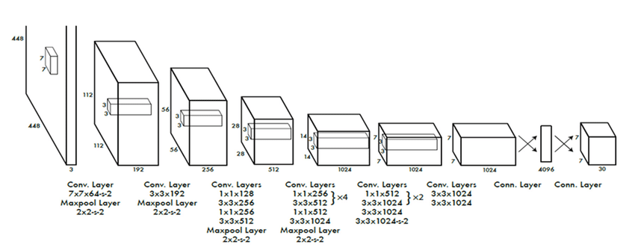Fig 1. Architecture Diagram of YOLO (Source: ResearchGate)

MobileNetV2 is tailored to be optimized for performance on mobile and embedded platforms. It employs depthwise separable convolutions to reduce computational expense considerably without any loss in accuracy. The efficiency of MobileNetV2 for image classification into five prevalent dental ailments, i.e., caries, calculus, hypodontia, ulcer, and gingivitis, is evaluated in this research. Its lightness and fast inference make it a strong contender to be integrated into mobile apps such as ToothBuddy.

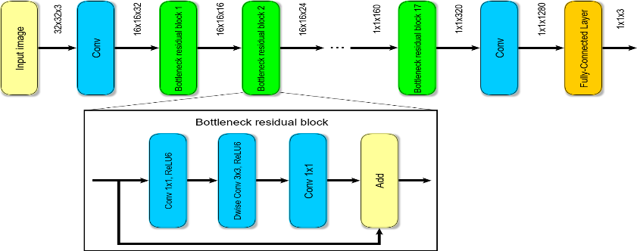Fig 2. Architecture Diagram of MobileNetV2 (Source: ResearchGate)

DenseNet is evaluated for its high classification accuracy and ability to detect complex patterns in dental images. The architecture offers connectivity among all layers, which improves gradient propagation and feature reuse. DenseNet is very effective especially in cases where patterns of disease are subtle or overlapping, thus offering higher reliability in challenging cases of diagnosis.

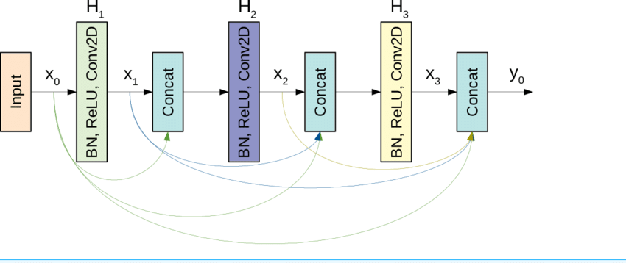

Fig 3. Architecture Diagram of DenseNet (Source: ResearchGate)

After the thorough assessment of all three models, the one with the best balance of accuracy, speed, and model size is selected for implementation within the ToothBuddy mobile app. The app allows users to take pictures of their oral cavity, which are then used to provide immediate diagnostic feedback based on the prediction of the model. Next, it produces a comprehensive report including disease detection, severity analysis, and any prior recorded dental history in the user's profile. In addition, ToothBuddy facilitates access to dental care by enabling users to book appointments for in-person consultations and consult with dentists via video calls or online chat. The diagnostic report is automatically sent to the consulting dentist, who may then provide professional feedback, prescribe required medications, or refer the patient for further treatment. This integrated approach ensures timely and accessible dental services, especially for users located in remote or underserved areas.



Fig 4. Block Diagram of ToothBuddy App

**Result & its interpretation:**

In the current research, the efficiency of three models—MobileNetV2, DenseNet, and YOLO—to identify various oral diseases was compared. A dataset of dental images containing five targeted oral diseases—caries, calculus, hypodontia, ulcer, and gingivitis—was used to test and train the models. The foremost challenge in comparing the models here was to identify the accuracy of each model in detecting and classifying these diseases. The results of the performance of all the models are explained in detail in the subsequent sections.

MobileNetV2 was exceptionally good at the classification of ailments like ulcer, calculus, hypodontia, and gingivitis. Mobile-optimized and lightweight architecture provided effective real-time classification with a high degree of accuracy and a low computational footprint, which is perfect for disease detection on the mobile platform.

Step 1: Image Preprocessing

Resize the input dental image (e.g., to 224×224 pixels), normalize pixel values between 0–1, and convert it to a tensor.

Step 2: Feature Extraction with MobileNetV2

Apply depthwise separable convolutions to limit parameters and computations. Utilize inverted residual blocks, where the input goes through an expansion layer, depthwise convolution, and a projection layer to preserve essential features in an effective manner.

Step 3: Disease Classification

Use Global Average Pooling (GAP) to reduce the feature dimensionality, then process using a fully connected layer. Use the Softmax function to classify the image into one of the given disease categories.

Phase 4: Results and Forecasting

Compute probability scores across all categories. Pick the top-scoring disease. If any of the scores are above some cutoff (say 0.5), leave the result marked as "No Disease Detected." Employ batch normalization and ReLU6 activation throughout for better performance and stability.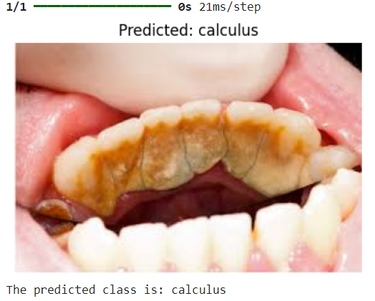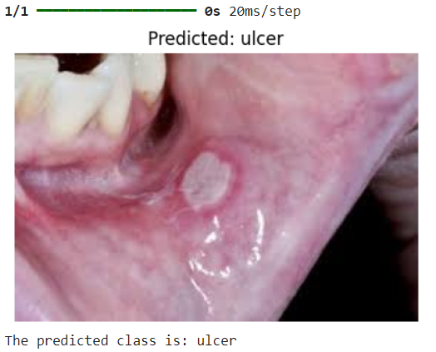

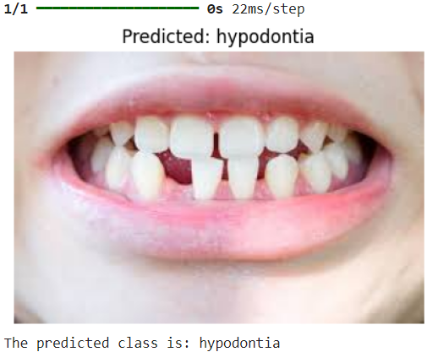Fig 5 : Results of Mobile Net Model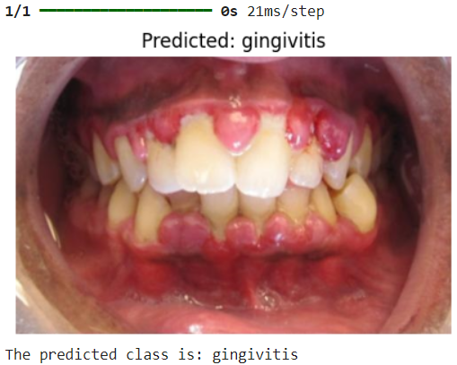

DenseNet was selected for ulcer detection because of its densely connected nature, which enables accurate identification in complicated cases with subtle presentations. The model's capacity to reuse features from earlier layers assists in the detection of subtle details, hence making it extremely reliable for the identification of visually subtle or early-stage ulcers.

Step 1: Image Preprocessing

Resize the input image (e.g., 224×224 pixels), normalize pixel values to the 0–1 range, and convert the image to a tensor format suitable for deep learning.

Step 2: Feature Extraction through Dense Connectivity

Pass the image through a series of convolutional layers with each layer taking input from all the previous ones. Lower layers detect general features, while deeper layers detect more specialized, disease-specific patterns.

Step 3: Ulcer-Specific Feature Improvement

Leverage DenseNet's feature reuse in order to retain delicate visual cues. This is especially useful for the detection of early ulcers that have minimal discoloration or weak visual cues.

Step 4: Classification

Pass the features that have been extracted through a Global Average Pooling (GAP) layer and a fully connected layer. Use a Softmax function to predict whether an ulcer exists.

Step 5: Forecasting Results

Compute the ulcer existence probability. If the measure of confidence is greater than some threshold value (e.g., 0.5), classify the image as "Ulcer Detected." Provide the final classification outcome and probability score.

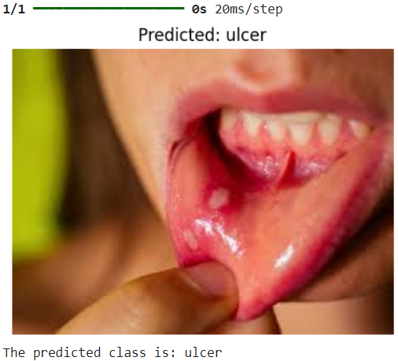

Fig 6 : Result of Dense Net Model

YOLO was employed for object detection in real-time in dental images for the detection of areas of ulcers, caries, and gingivitis. Its speed processing feature makes it suitable for improving the user experience in mobile apps. YOLO not only detects areas for further classification by models such as MobileNetV2 and DenseNet but also classifies these diseases directly at high speed and accuracy.

Step 1: Image Preprocessing

Resize the input image (e.g., 416×416 pixels), normalize pixel values to the 0–1 range, and convert to a deep learning-compatible tensor.

Step 2: Grid-Based Division

Subdivide the image into an S × S grid (usually 7×7). Each cell in the grid is tasked with detecting objects whose centers lie within it.

Step 3: Bounding Box and Confidence Prediction

Each grid cell predicts bounding boxes defined by center coordinates (x, y), width (w), and height (h). The final confidence score is calculated as:

Final Score = Confidence Score * Class Probability

Step 4: Non-Maximum Suppression (NMS)

Use NMS to remove duplicate boxes by keeping only the highest-confidence ones. Use Intersection over Union (IoU) to calculate the most precise bounding box for each detected object.

Step 5: Output Generation

The output is bounding boxes specifying detected areas, predicted category labels (e.g., gingivitis, caries, ulcer), and confidence values for every detection.

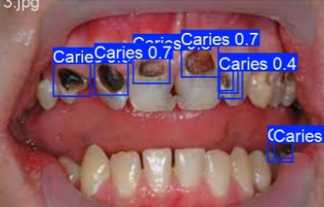

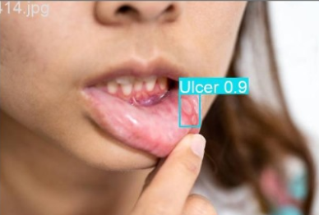

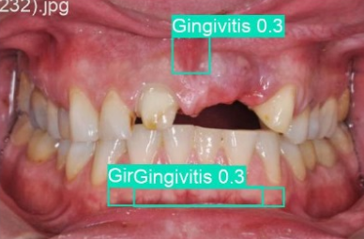

Fig 7 : Results of YOLO Model

| Model | Accuracy |
| --- | --- |
| DenseNet | 57% |
| MobileNetV2 | 67% |
| YOLOv8 | 92% |

Table 1. Models and their accuracies

Together, the three models—YOLO, MobileNetV2, and DenseNet—developed a strong and efficient framework for detecting multiple dental diseases through image analysis. Each model played a special role in the overall performance of the system: YOLO facilitated quick and precise localization of the affected region, MobileNetV2 processed classification over a range of diseases with ease, and DenseNet demonstrated better performance in detecting ulcers, particularly in cases involving visual subtleties. The collaborative work of these models significantly enhanced the speed and accuracy of diagnosis, and their integration into the ToothBuddy system was particularly useful for mobile-based oral health solutions. The evaluation results, based on labeled image outputs, validated the system's high capability to provide quick and reliable dental diagnoses through smartphones. Following a thorough assessment of the three models, YOLO was chosen for final integration into the ToothBuddy application due to its real-time capability and high degree of reliability in oral disease detection.

The ToothBuddy system consists of two standalone mobile applications—one for patients and one for dental professionals—built using React Native to provide cross-platform compatibility. On the patient's end, users can take a photo of their oral cavity via their smartphone. The built-in YOLO model then processes the taken image to detect dental problems like caries, gingivitis, coloration of teeth, calculus, or ulcers, providing a diagnosis with the respective confidence score from the model. A general report is provided, which includes the diagnosis, date, time, image, and prediction confidence, allowing patients to keep this information handy for future use. In case additional guidance is needed, users can schedule an in-person consultation by choosing their preferred date and time or may opt for an online consultation via chat or video call. For further assistance, an in-built chatbot provides initial first-aid treatment and continuous advice pertaining to dental care.

Fig 8. Patients App

The online consultation functionality is driven by Jitsi Meet, which supports live video calls, and Firebase manages authentication and database operations for the two apps.

On the dental side, clinicians are able to view scheduled appointments and conduct online consultations, with instant chat and video communication with patients at their fingertips. The built-in system ensures a seamless, AI-powered dental diagnosis and treatment process, extending professional care to everyone—especially those in underserved or distant areas.



Fig 9. Dentists App

**Conclusion:**

The success of deep models in the practical diagnosis of oral diseases via comparative assessment is documented in this work. Out of the models under assessment, the highest accuracy, shortest inference time, and ability to identify a number of diseases from a single image made YOLO best for inclusion within mobile applications. Although MobileNetV2, EfficientNet, ResNet, and VGG16 performed acceptably well across accuracy and efficiency, YOLO excelled based on the real-time nature of its object detection and effectiveness on the mobile platform.

The ToothBuddy mobile app fills the gap between AI-diagnosis and accessible oral health. It provides a simple interface for patients to take photos of their oral cavity and get immediate diagnostic feedback. The system produces an elaborate report comprising the diagnosis, prediction confidence, image, date, and time. Patients may save the report, schedule a face-to-face consultation, or go for online consultation through chat or video call, powered by Jitsi Meet. Moreover, an in-built chatbot provides first-aid advice and general dental care tips.

The dentists' software makes it easy to manage scheduled appointments as well as online consultations in real time. Both the software applications, which were created with React Native and supported by Firebase for backend support and database management, ensure seamless operation and trouble-free communication between dentists and patients.

In the future, further improvement in the real-time performance of the model can be achieved through methods such as quantization and pruning, and generalizability can be improved through increasing the dataset with a wider variety of oral disorders. In general, this paper introduces a novel, scalable, and accurate AI-driven dental diagnosis solution that enhances accessibility and efficiency in oral care provision.

**Acknowledgement:**

We are grateful to our college Vivekanand Education Society's Institute of Technology, for reviewing our project and assisting us at every stage while we were gathering data for it. It is with immense pleasure that we would like to extend our sincere gratitude to all of them for their meticulous assistance, useful suggestions, and advice during the course of the project work, and for their guidance and offering advice.

**References:**

[1]Mohandas, Dr.R. & Sundareswaran, Veena & Reddy, K. & Yaswanth, C. & Jaswanth, N.. (2023). An Intelligent System for Dental Disease Detection Using Smart R-CNN Technique. Migration Letters. 20. 341-347. 10.59670/ml.v20iS13.6464.

[2] Tobias, Guy & Spanier, Assaf. (2020). Developing a Mobile App (iGAM) to Promote Gingival Health by Professional Monitoring of Dental Selfies: User-Centered Design Approach. JMIR mhealth and uhealth.

[3] Xiao, Jin & Luo, Jiebo & Ly-Mapes, Oriana & Wu, Tong & Dye, Timothy & Jallad, Nisreen & Hao, Peirong & Ruan, Jinlong & Bullock, Sherita & Fiscella, Kevin. (2021). Assess A Smartphone App (AICaries) that uses artificial intelligence to detect dental caries in children and provide interactive oral health education: Protocol for design and usability testing (Preprint). JMIR Research Protocols. 10. 10.2196/32921.

[4]Anantharaman, Rajaram & Velazquez, Matthew & Lee, Yugyung. (2018). Utilizing Mask R-CNN for Detection and Segmentation of Oral Diseases. 2197-2204. 10.1109/BIBM.2018.8621112.

[5] Liu, Lizheng & Xu, Jiawei & Huan, Yuxiang & Zou, Zhuo & Yeh, Shih-Ching & Zheng, Lirong. (2019). A Smart Dental Health-IoT Platform Based on Intelligent Hardware, Deep Learning and Mobile Terminal. IEEE journal of biomedical and health informatics. PP. 10.1109/JBHI.2019.2919916.

[6] Väyrynen, Elina & Hakola, Sanna & Keski-Salmi, Anniina & Jämsä, Hanna-Leena & Vainionpää, Raija & Karki, Saujanya. (2023). The Use of Patient-Oriented Mobile Phone Applications in Oral Health: A Scoping Review. JMIR mhealth and uhealth. 11. 10.2196/46143.

[7]Safaldin, M., Zaghden, N., & Mejdoub, M. (2024). An improved YOLOv8 to detect moving objects. *IEEE Access*.

[8]Ali, M. A., Fujita, D., & Kobashi, S. (2023). Teeth and prostheses detection in dental panoramic X-rays using CNN-based object detector and a priori knowledge-based algorithm. *Scientific Reports*, *13*(1), 16542.

[9] Thulaseedharan, A., & PS, L. P. (2022, November). Deep learning based object detection algorithm for the detection of dental diseases and differential treatments. In *2022 IEEE 19th India Council International Conference (INDICON)* (pp. 1-7). IEEE.

[10] Lian, L., Zhu, T., Zhu, F., & Zhu, H. (2021). Deep learning for caries detection and classification. *Diagnostics*, *11*(9), 1672.

**b. Plagiarism Report**

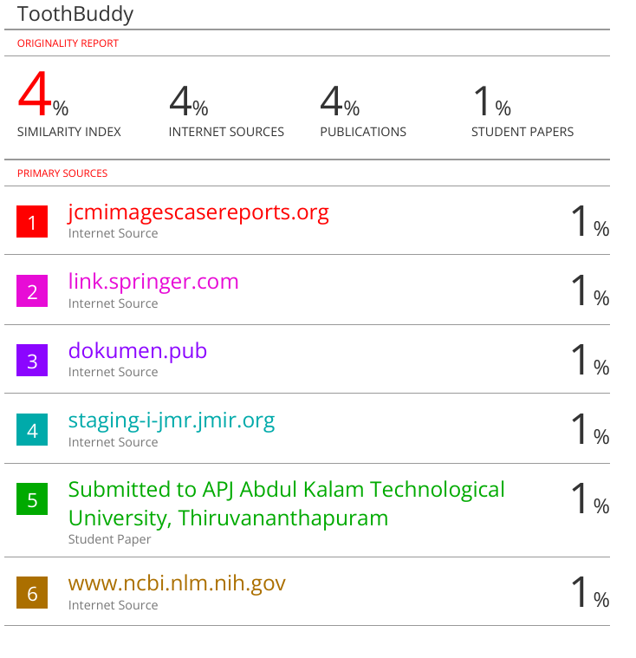

**c. Review Sheets**

Review 1 Sheet

